**Course Submission Cover Sheet  
Module:** CC6012 Data and Web Application **Deadline:** 3PM, xx of March 2024  
**Module Leader:** Dr Sandra Fernando

**Student ID:**

Acknowledgement

Table of Contents

System Requirements 4

Database Generation 6

Specification of database relations 6

Relational ER Diagram 6

Data Dictionary 7

Generation of Database – Using SQL Server 9

Data Models of the CW tables and generated table structures. 9

Input data into DB tables (INSERT) 12

Display data in the tables (SELECT) 18

Logical ER Diagram 20

Implementation of the Web-based Database Application 21

Testing 35

User manual 40

Further discussion 42

Table of Figure

Figure 1: Relational ER Diagram 7

Figure 2 : Insert Book Details 15

Figure 3 : Insert Student Details 16

Figure 4 : Insert Book Issue Details 17

Figure 5 : Insert CD Details 18

Figure 6: Insert Admin Details 19

Figure 7 : Book Table 20

Figure 8 : Student Details 20

Figure 9 : CD Table 21

Figure 10 Book Issue Table 21

Figure 11 : Admin Table 21

Figure 12 : Logical ER Diagram 22

Figure 13 : Home Page 23

Figure 14: Login Page 23

Figure 15: Login Page 1 24

Figure 16 : Login Successfully Page 24

Figure 17 : Student Table 25

Figure 18 : Student Add 25

Figure 19 : Student Add 1 26

Figure 20 : Student Add Successfully Page 26

Figure 21 : Edit Student Page 27

Figure 22 : Student Details Edit Successfully Page 27

Figure 23: Delete Student Page 28

Figure 24: Book Page 28

Figure 25: Add Book Details 29

Figure 26: Edit Book Details 30

Figure 27: Delete Book Details 31

Figure 28: CD Page 32

Figure 29 : Add CD Details 32

Figure 30: Edit CD Details 34

Figure 31: Delete CD Details 35

Figure 32 : Issue Book Page 35

Figure 33: New Book Issue Page 36

Figure 34: Search page 37

# System Requirements

1. Home Page

**Feature**: Display company information and provide sign-in links for the admin.

**Details**: Static content with company information (e.g., mission, vision, services).

Sign-in links for admin access.

1. Admin Functionality

**Feature**: Admin can sign in.

**Details**: Admin authentication (username and password).

**Feature**: Admin can add/delete books/CDs details.

**Details**:

Form to enter book/CD details (title, author, subject, ISBN, publication year, type, etc.).

Delete functionality for removing book/CD entries.

**Feature**: Admin can edit/update books/CDs details.

**Details**: Editable form to update existing book/CD details.

**Feature**: Admin can issue a book and update returns.

**Details**: Issue book form (book ID, student ID, issue date, return date).

Update return status and date.

**Feature**: Admin can view all books and CDs.

**Details**: List view of all books and CDs with search, filter, and sort options.

1. Guest Functionality

**Feature**: Guests can search for books.

**Details**: Search bar with options to filter by title, author, subject, etc.

**Feature**: Guests can reserve books.

**Details**:

Reservation form (guest details, book ID).

Confirmation message on successful reservation.

**Feature**: Guests can leave a message.

**Details**:

Contact form (name, email, message).

Submit button to send the message to the admin.

1. Database Requirements

**Entities**:

Admin: Username, Password.

Book: BookID, BookReferenceNumber, Title, Author, Category, ISBN, Publication, PublicationYear, Edition, AvailabilityCopy, NoOfCopy

CD: CdID, CdTitle, Author, Category, Publication, PrintedYear

Issue: IssueID, BookID, StudentID, IssueDate, ReturnDate.

Student: StudentID, FirstName, LastName, ID, Email, Address, Telephone, RegisteredDate, TerminatedDate.

# Database Generation

## Specification of database relations

### Relational ER Diagram

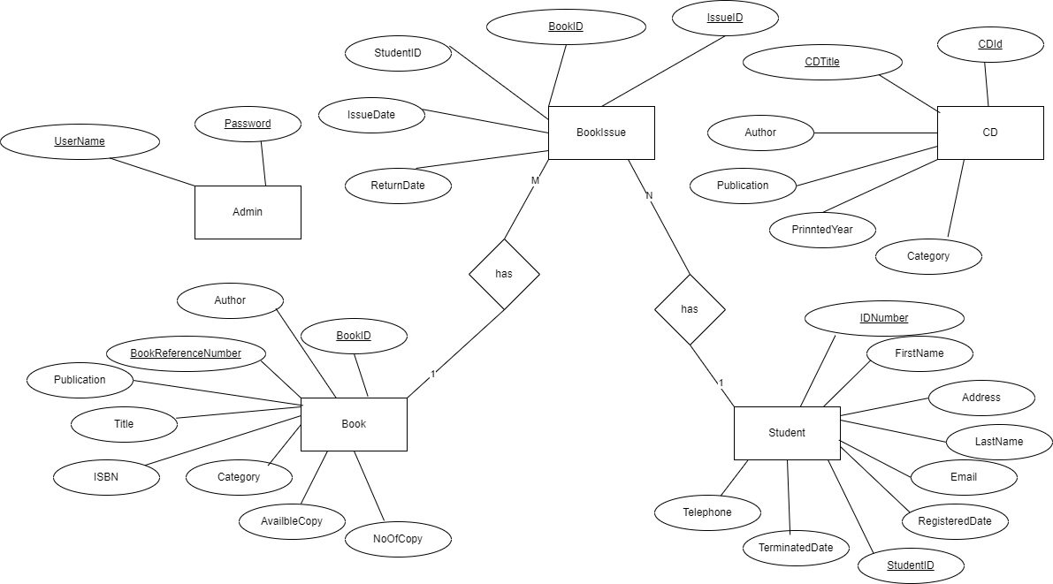

Figure 1: Relational ER Diagram

### Data Dictionary

LIBRARY_BOOK Table

Attributes:

BOOK_ID: INT, Primary Key, Identity

BOOK_REFERENCE_NUMBER: NVARCHAR(50), Not Null

TITLE: NVARCHAR(255), Not Null

ISBN: NVARCHAR(20), Not Null, Unique

AUTHOR: NVARCHAR(255), Not Null

PUBLICATION: NVARCHAR(255), Nullable

EDITION: NVARCHAR(50), Nullable

PUBLISHED_YEAR: INT, Nullable

CATEGORY: NVARCHAR(100), Nullable

NO_OF_COPY: INT, Nullable

AVAILBLE_COPY: INT, Nullable

Constraints:

Primary Key: BOOK_ID

Unique Constraint: ISBN

Not Null Constraints: BOOK_REFERENCE_NUMBER, TITLE, ISBN, AUTHOR

LIBRARY_STUDENT Table

Attributes:

STUDENT_ID: INT, Primary Key, Identity

ID_NUMBER: NVARCHAR(15), Not Null

FIRST_NAME: NVARCHAR(100), Not Null

LAST_NAME: NVARCHAR(100), Not Null

EMAIL: NVARCHAR(255), Not Null, Unique

ADDRESS: NVARCHAR(255), Nullable

TELEPHONE: NVARCHAR(20), Nullable

REGISTERED_DATE: DATE, Not Null

TERMINATED_DATE: DATE, Nullable

Constraints:

Primary Key: STUDENT_ID

Unique Constraint: EMAIL

Not Null Constraints: ID_NUMBER, FIRST_NAME, LAST_NAME, EMAIL, REGISTERED_DATE

LIBRARY_ISSUE_BOOKS Table

Attributes:

ISSUE_ID: INT, Primary Key, Identity

BOOK_ID: INT, Not Null, Foreign Key

STUDENT_ID: INT, Not Null, Foreign Key

ISSUE_DATE: DATE, Not Null

RETURN_DATE: DATE, Not Null

Constraints:

Primary Key: ISSUE_ID

Foreign Key: BOOK_ID references LIBRARY_BOOK(BOOK_ID)

Foreign Key: STUDENT_ID references LIBRARY_STUDENT(STUDENT_ID)

Not Null Constraints: BOOK_ID, STUDENT_ID, ISSUE_DATE, RETURN_DATE

LIBRARY_CD Table

Attributes:

CD_ID: INT, Primary Key, Identity

CD_TITLE: NVARCHAR(255), Not Null

AUTHOR: NVARCHAR(255), Not Null

PUBLICATION: NVARCHAR(255), Nullable

PRINTED_YEAR: INT, Nullable

CATEGORY: NVARCHAR(100), Nullable

Constraints:

Primary Key: CD_ID

Not Null Constraints: CD_TITLE, AUTHOR

LIBRARY_ADMIN Table

Attributes:

USER_ID: NVARCHAR(100), Primary Key, Not Null

PASSWORD: NVARCHAR(100), Not Null

Constraints:

Primary Key: USER_ID

Not Null Constraints: USER_ID, PASSWORD

## Generation of Database – Using SQL Server

### Data Models of the CW tables and generated table structures.

CREATE DATABASE LIBRARY_DB;

GO;

USE LIBRARY_DB;

GO;

CREATE TABLE LIBRARY_BOOK

(

BOOK_ID INT PRIMARY KEY IDENTITY,

BOOK_REFERENCE_NUMBER NVARCHAR(50) NOT NULL,

TITLE NVARCHAR(255) NOT NULL,

ISBN NVARCHAR(20) NOT NULL UNIQUE,

AUTHOR NVARCHAR(255) NOT NULL,

PUBLICATION NVARCHAR(255),

EDITION NVARCHAR(50),

PUBLISHED_YEAR INT,

CATEGORY NVARCHAR(100),

NO_OF_COPY INT,

AVAILBLE_COPY INT

);

CREATE TABLE LIBRARY_STUDENT (

STUDENT_ID INT PRIMARY KEY IDENTITY,

ID_NUMBER NVARCHAR(15) NOT NULL,

FIRST_NAME NVARCHAR(100) NOT NULL,

LAST_NAME NVARCHAR(100) NOT NULL,

EMAIL NVARCHAR(255) NOT NULL UNIQUE,

ADDRESS NVARCHAR(255),

TELEPHONE NVARCHAR(20),

REGISTERED_DATE DATE NOT NULL,

TERMINATED_DATE DATE

);

CREATE TABLE LIBRARY_ISSUE_BOOKS (

ISSUE_ID INT PRIMARY KEY IDENTITY,

BOOK_ID INT NOT NULL,

STUDENT_ID INT NOT NULL,

ISSUE_DATE DATE NOT NULL,

RETURN_DATE DATE NOT NULL,

FOREIGN KEY (BOOK_ID) REFERENCES LIBRARY_BOOK(BOOK_ID),

FOREIGN KEY (STUDENT_ID) REFERENCES LIBRARY_STUDENT(STUDENT_ID)

);

CREATE TABLE LIBRARY_CD

(

CD_ID INT PRIMARY KEY IDENTITY,

CD_TITLE NVARCHAR(255) NOT NULL,

AUTHOR NVARCHAR(255) NOT NULL,

PUBLICATION NVARCHAR(255),

PRINTED_YEAR INT,

CATEGORY NVARCHAR(100)

);

CREATE TABLE LIBRARY_ADMIN

(

USER_ID NVARCHAR(100) PRIMARY KEY NOT NULL,

PASSWORD NVARCHAR(100) NOT NULL

);

### Input data into DB tables (INSERT)

LIBRARY_BOOK

INSERT INTO LIBRARY_BOOK (BOOK_REFERENCE_NUMBER, TITLE, ISBN, AUTHOR, PUBLICATION, EDITION, PUBLISHED_YEAR, CATEGORY, NO_OF_COPY, AVAILBLE_COPY)

VALUES

('REF123', 'Introduction to Computing', '978-0134672816', 'John Smith', 'Pearson', '3rd', 2018, 'Computing', 10, 8),

('REF124', 'Business Management Basics', '978-0198777252', 'Jane Doe', 'Oxford', '1st', 2015, 'Business', 5, 5),

('REF125', 'Advanced Programming', '978-0262033848', 'Alice Johnson', 'MIT Press', '2nd', 2017, 'Computing', 7, 7),

('REF126', 'Marketing Strategies', '978-0132716377', 'Robert Brown', 'Prentice Hall', '4th', 2019, 'Business', 8, 6),

('REF127', 'Database Systems', '978-0321197849', 'Michael Stonebraker', 'Addison-Wesley', '5th', 2020, 'Computing', 6, 6);

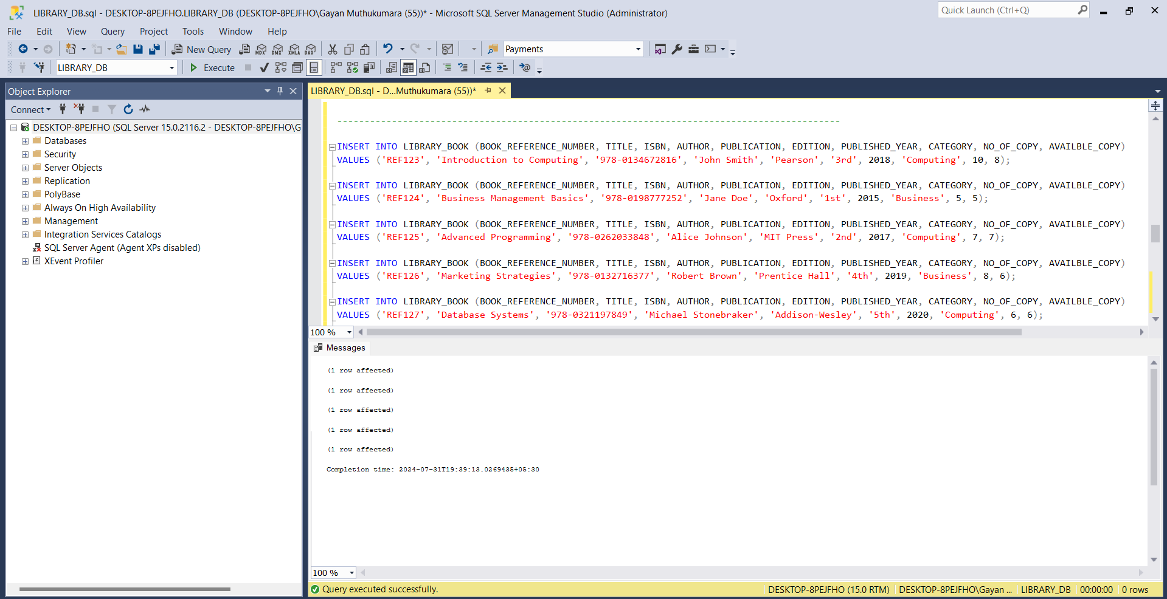

Figure 2 : Insert Book Details

LIBRARY_STUDENT

INSERT INTO LIBRARY_STUDENT (ID_NUMBER, FIRST_NAME, LAST_NAME, EMAIL, ADDRESS, TELEPHONE, REGISTERED_DATE, TERMINATED_DATE)

VALUES ('STU1001', 'Emily', 'Clark', 'emily.clark@example.com', '123 Elm Street', '555-1234', '2022-01-15', NULL),

('STU1002', 'David', 'Miller', 'david.miller@example.com', '456 Oak Avenue', '555-5678', '2022-02-10', NULL),

('STU1003', 'Sophia', 'Johnson', 'sophia.johnson@example.com', '789 Pine Road', '555-9101', '2022-03-05', NULL),

('STU1004', 'Liam', 'Smith', 'liam.smith@example.com', '321 Maple Lane', '555-1122', '2022-04-20', NULL),

('STU1005', 'Ava', 'Williams', 'ava.williams@example.com', '654 Birch Boulevard', '555-3344', '2022-05-15', NULL);

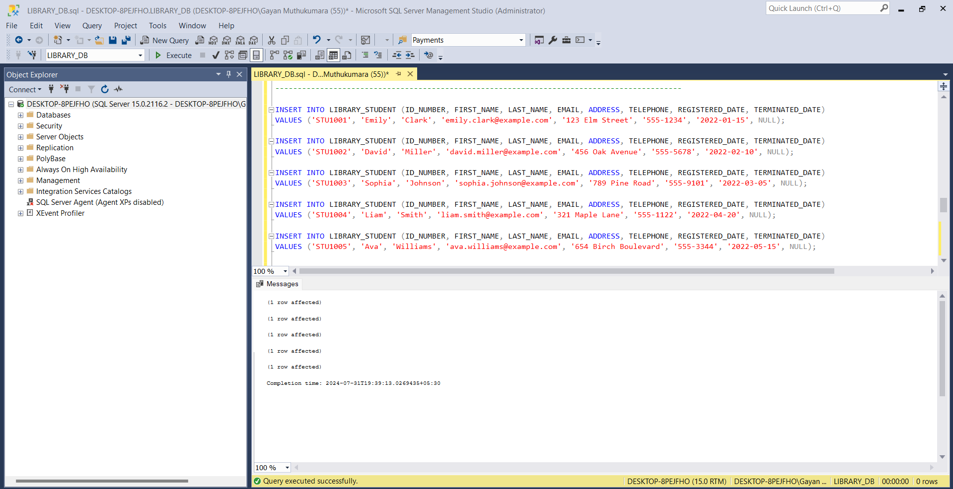

Figure 3 : Insert Student Details

LIBRARY_ISSUE_BOOKS

INSERT INTO LIBRARY_ISSUE_BOOKS (BOOK_ID, STUDENT_ID, ISSUE_DATE, RETURN_DATE)

VALUES

(1, 1, '2023-06-15', '2023-07-15'),

(2, 2, '2023-06-20', '2023-07-20'),

(3, 3, '2023-06-25', '2023-07-25'),

(4, 4, '2023-07-01', '2023-07-31'),

(5, 5, '2023-07-05', '2023-08-05');

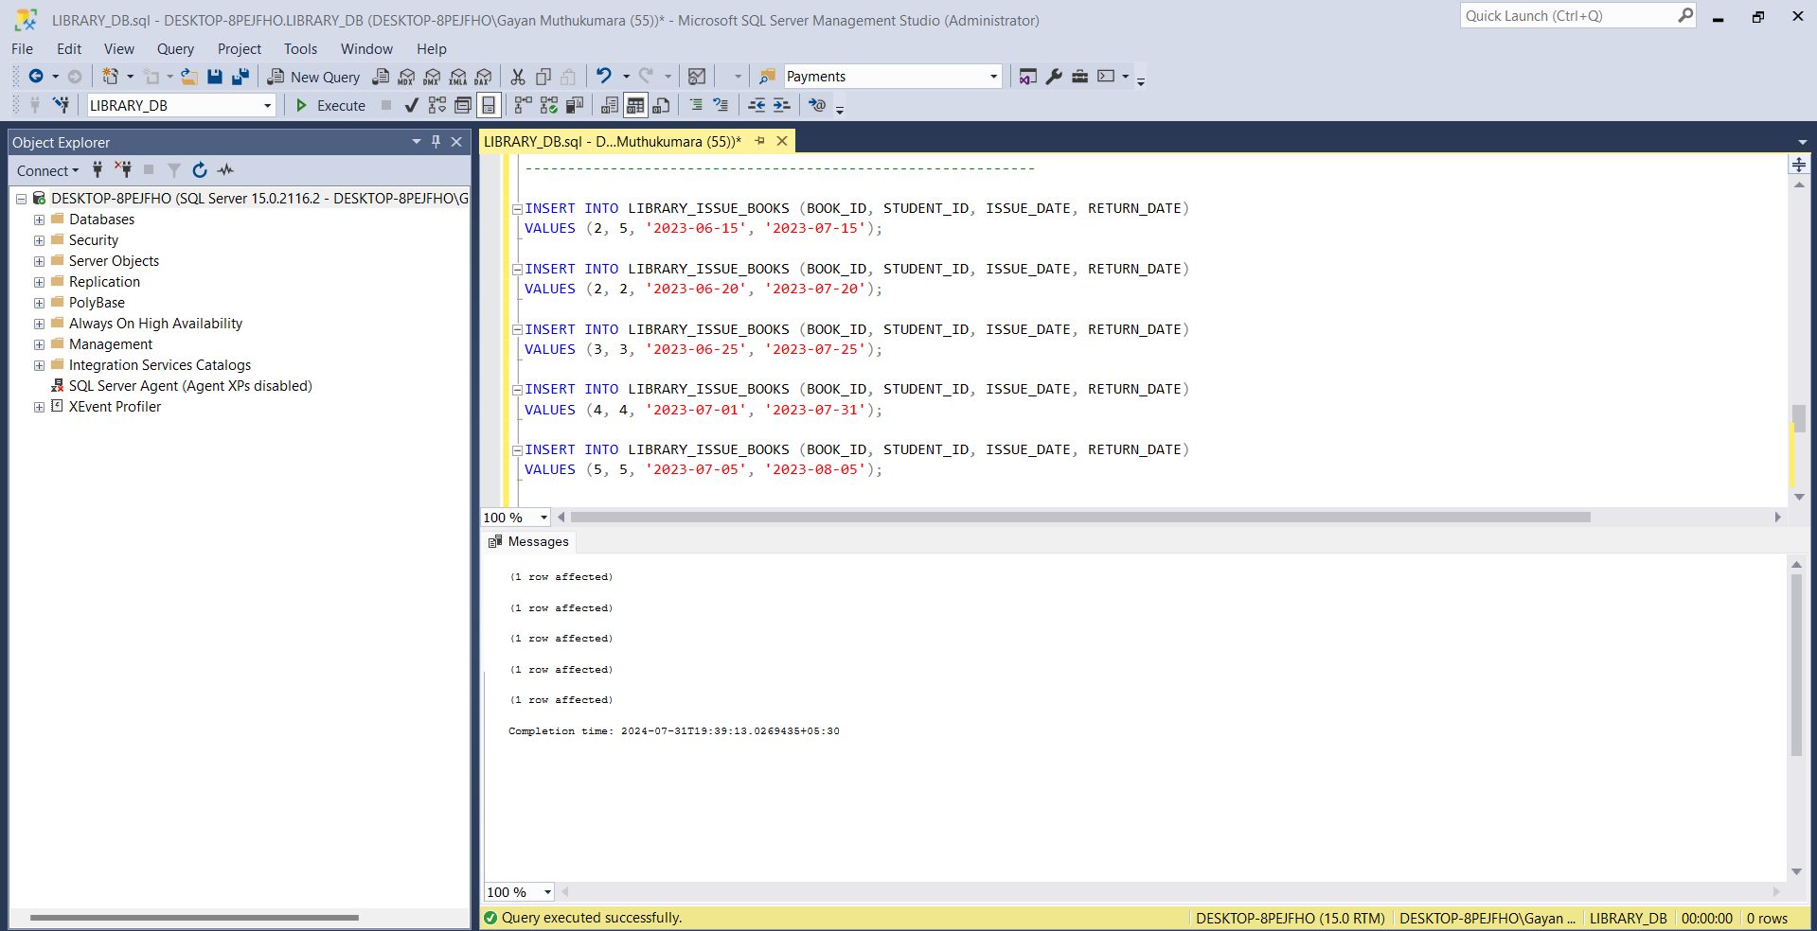

Figure 4 : Insert Book Issue Details

LIBRARY_CD

INSERT INTO LIBRARY_CD (CD_TITLE, AUTHOR, PUBLICATION, PRINTED_YEAR, CATEGORY)

VALUES

('Learn Python Programming', 'John Doe', 'Tech Publishing', 2021, 'Computing'),

('Business Ethics', 'Jane Smith', 'Business Press', 2019, 'Business'),

('Java for Beginners', 'Alice Williams', 'Code House', 2020, 'Computing'),

('Marketing 101', 'Robert Brown', 'Marketing Today', 2018, 'Business'),

('Advanced SQL Techniques', 'Michael Johnson', 'Database Publishers', 2022, 'Computing');

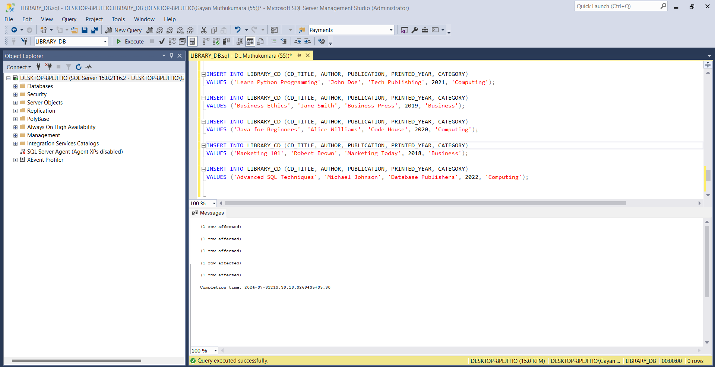

Figure 5 : Insert CD Details

LIBRARY_ADMIN

INSERT INTO LIBRARY_ADMIN (USER_ID, PASSWORD) VALUES ('Admin','Admin@#$123')

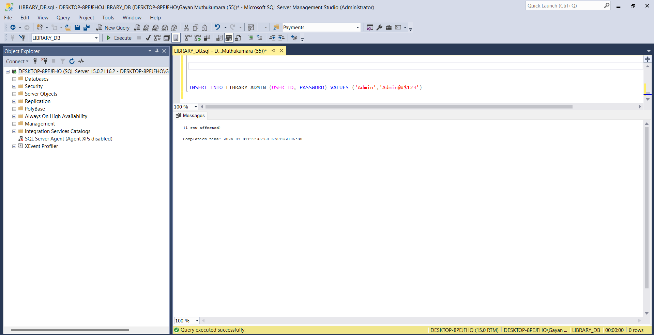

Figure 6: Insert Admin Details

### Display data in the tables (SELECT)

SELECT * FROM LIBRARY_BOOK

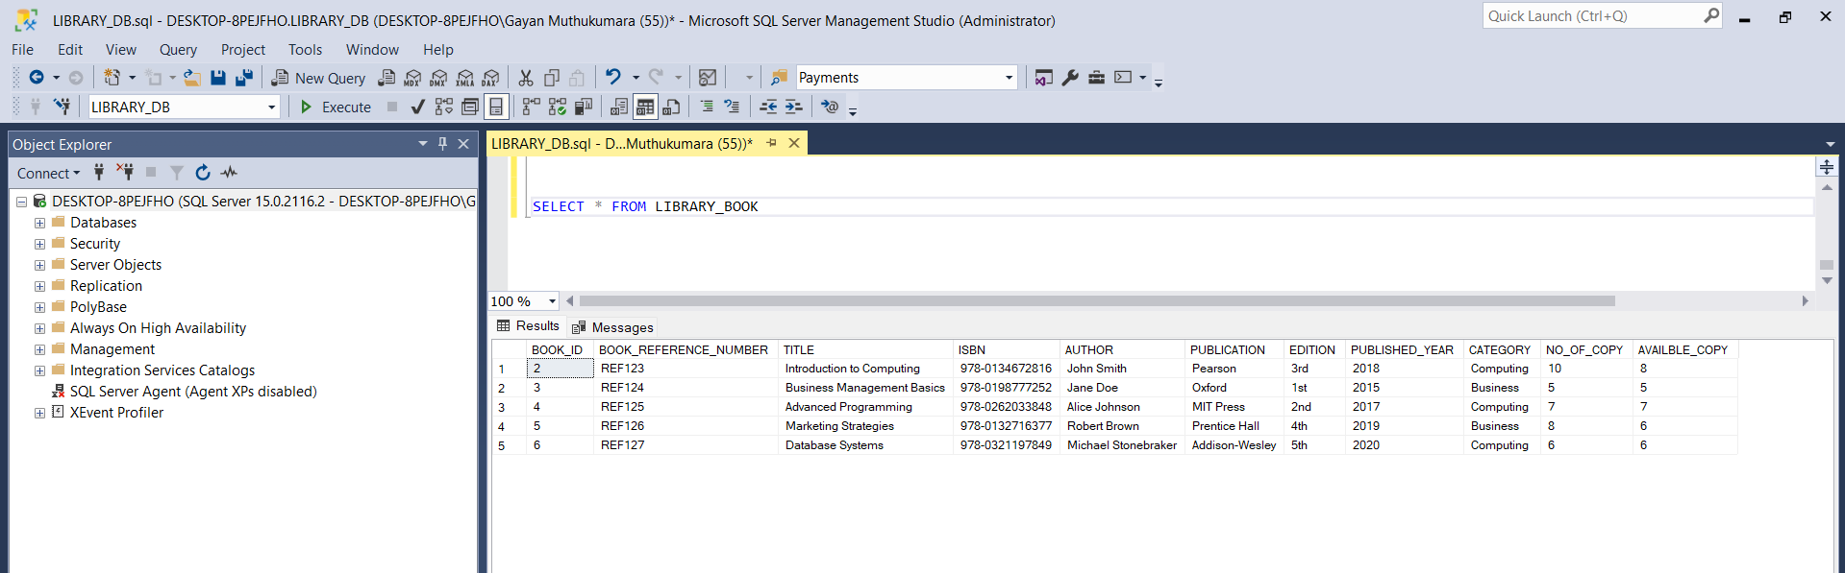

Figure 7 : Book Table

SELECT * FROM LIBRARY_STUDENT

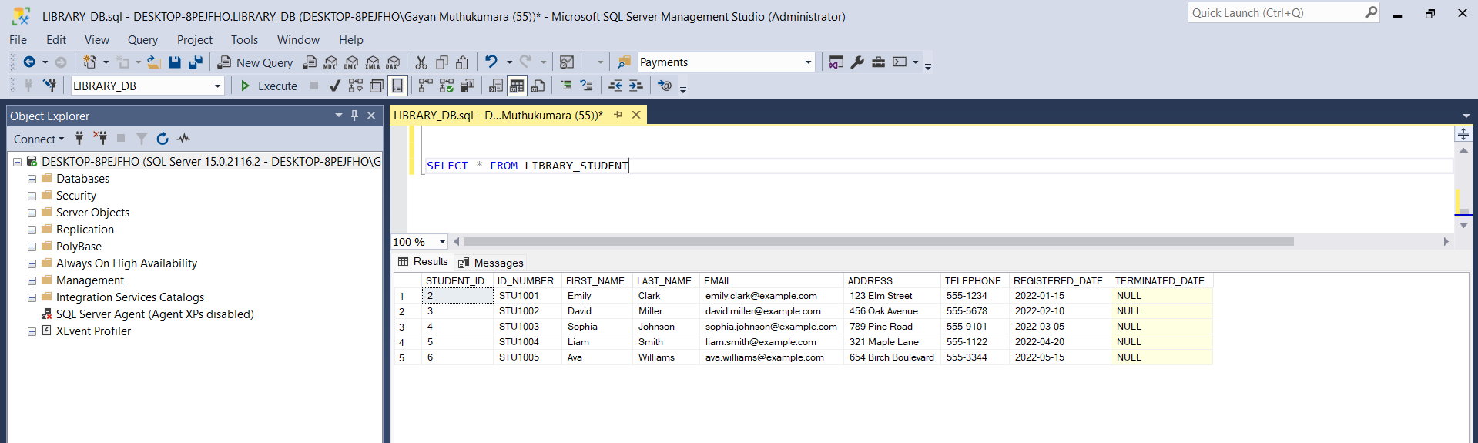

Figure 8 : Student Details

SELECT * FROM LIBRARY_CD

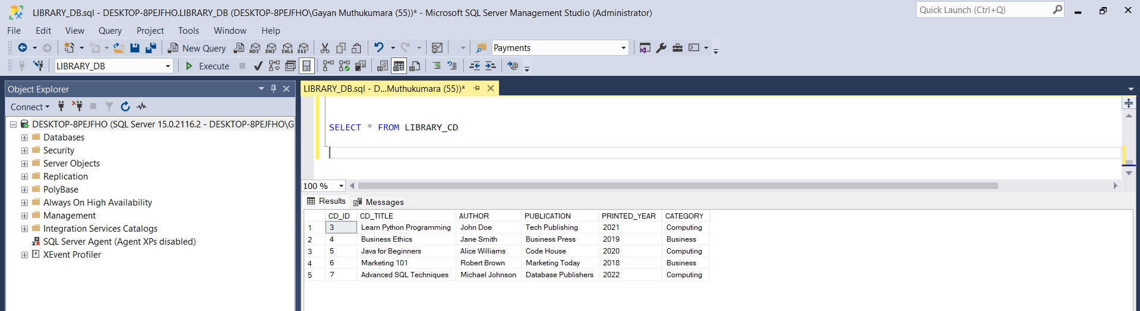  
SELECT * FROM LIBRARY_ISSUE_BOOKS

Figure 9 : CD Table

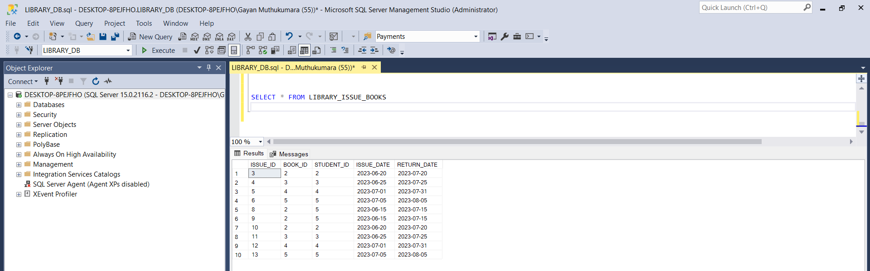

Figure 10 Book Issue Table

SELECT * FROM LIBRARY_ADMIN

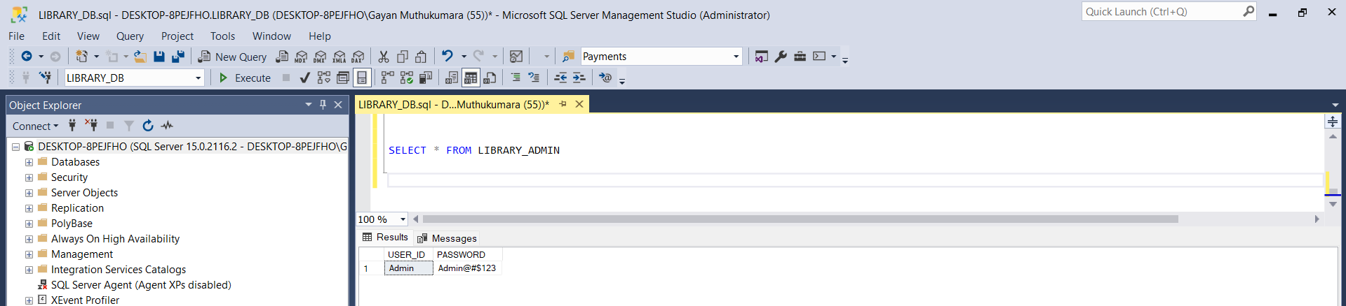

Figure 11 : Admin Table

### Logical ER Diagram

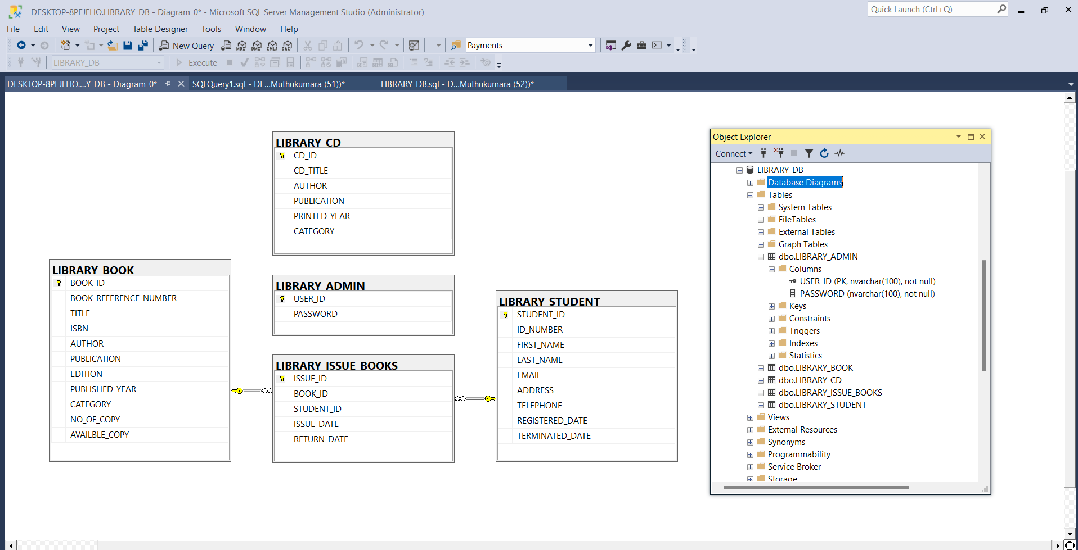

Figure 12 : Logical ER Diagram

# Implementation of the Web-based Database Application

Home Page

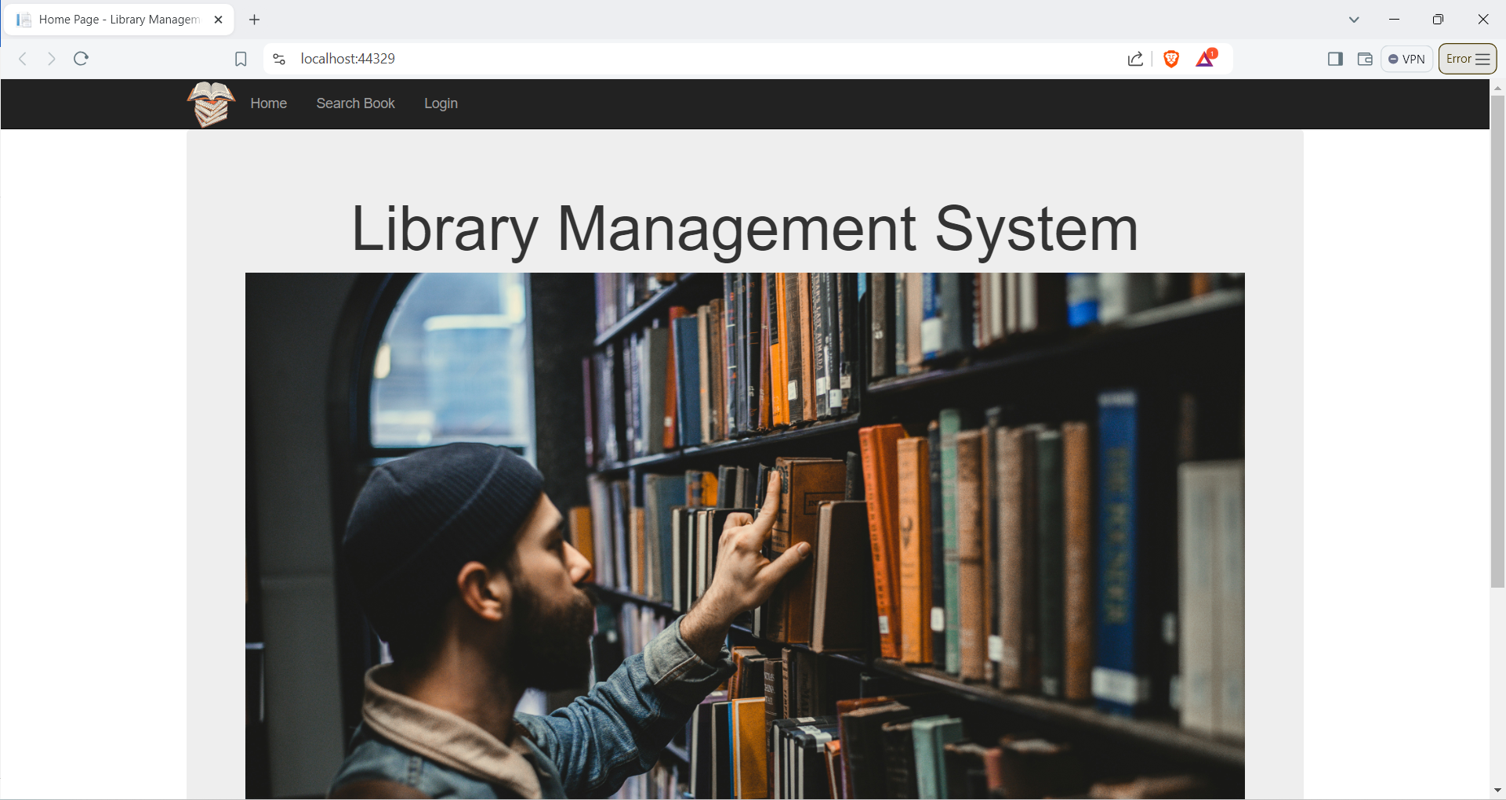

Figure 13 : Home Page

Login Page

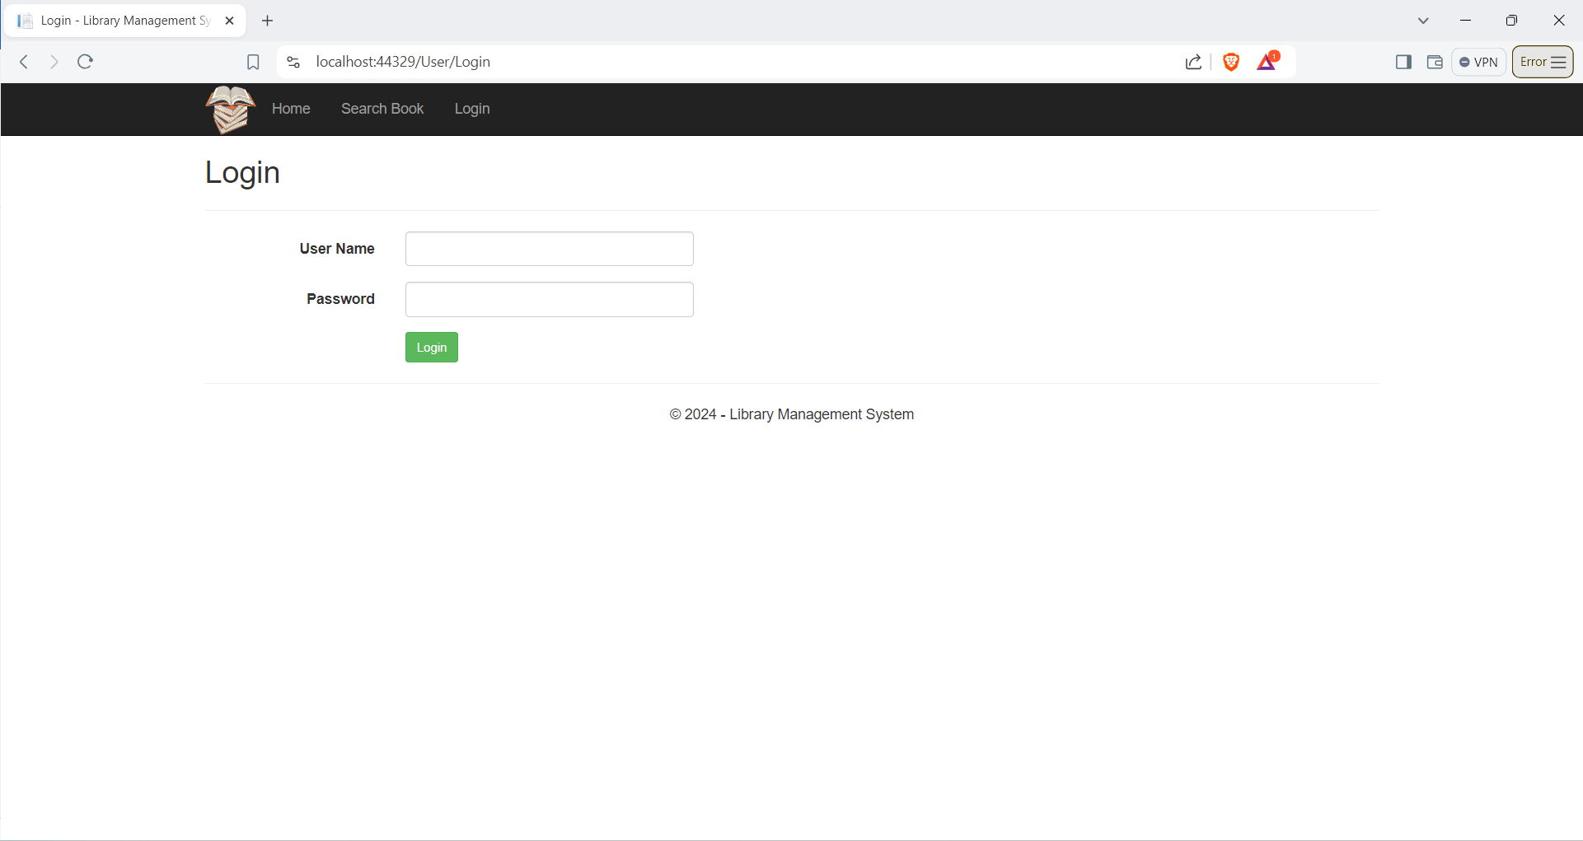

Figure 14: Login Page

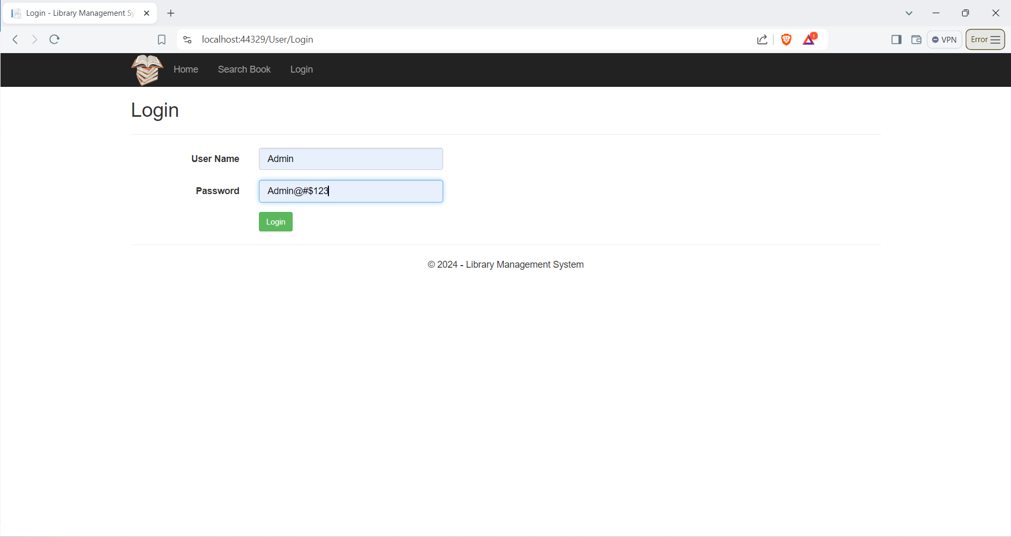

Figure 15: Login Page 1

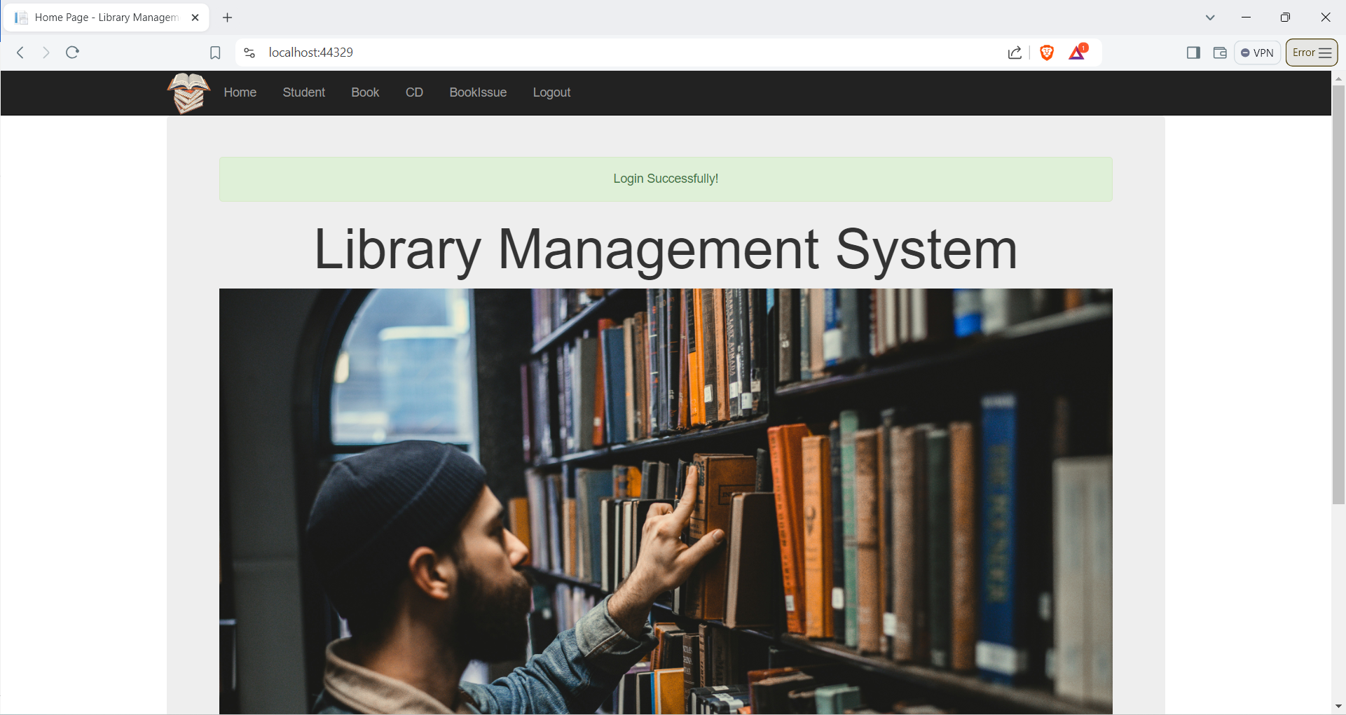

Figure 16 : Login Successfully Page

Student Page

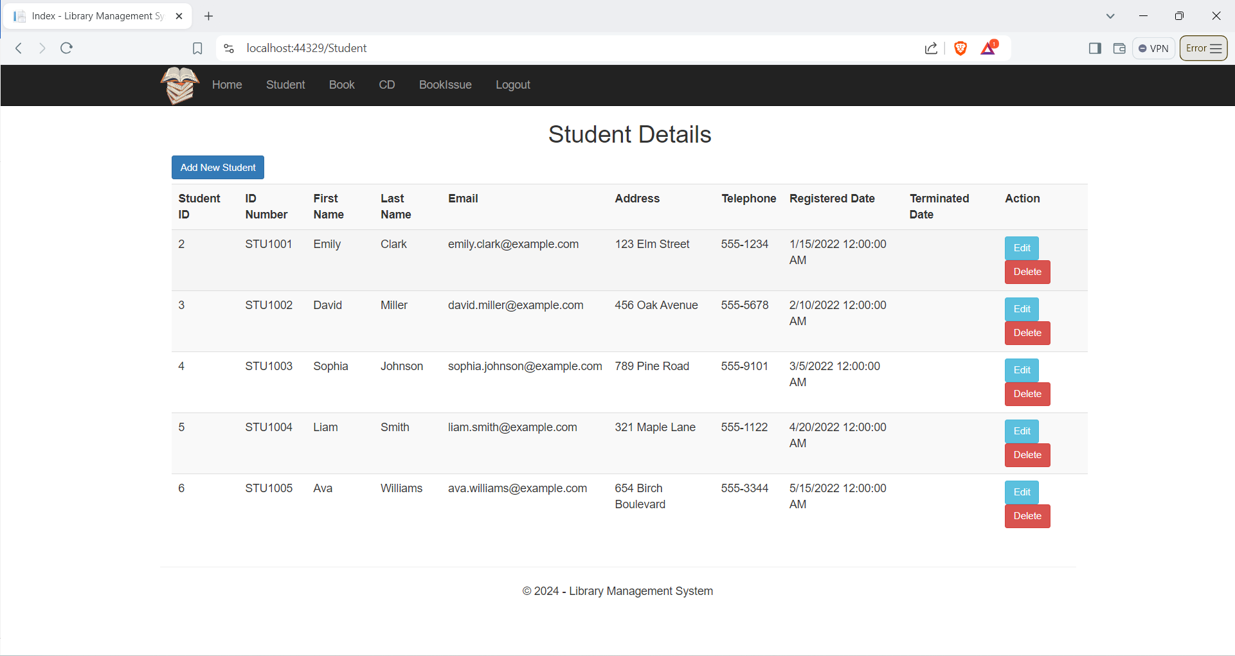

Figure 17 : Student Table

Add Student

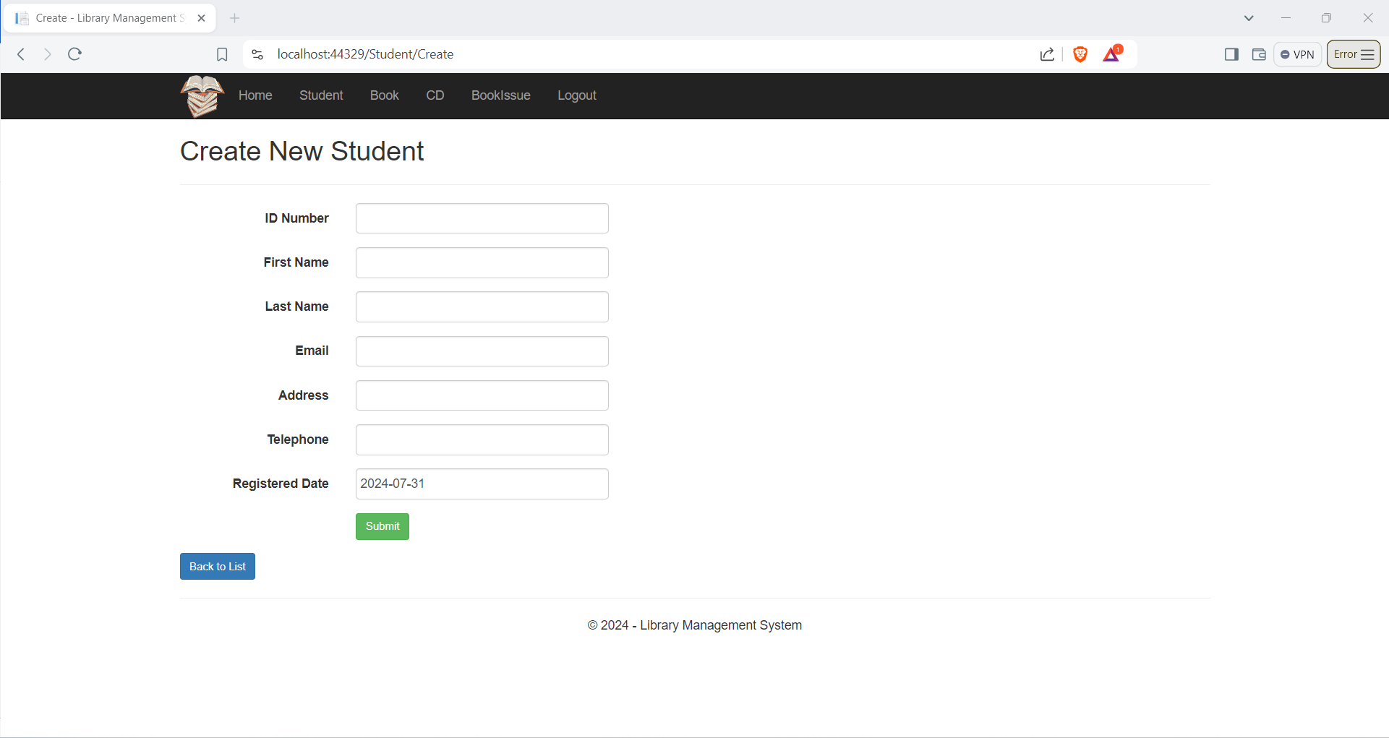

Figure 18 : Student Add

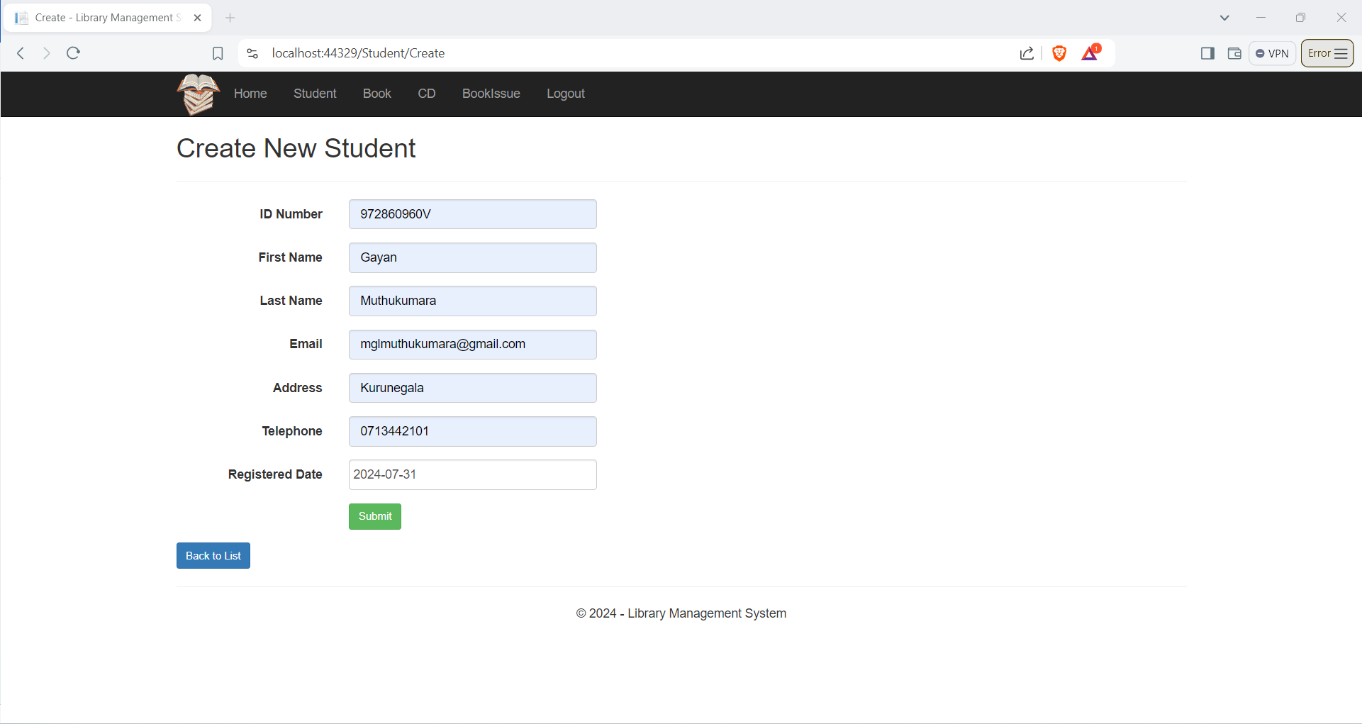

Figure 19 : Student Add 1

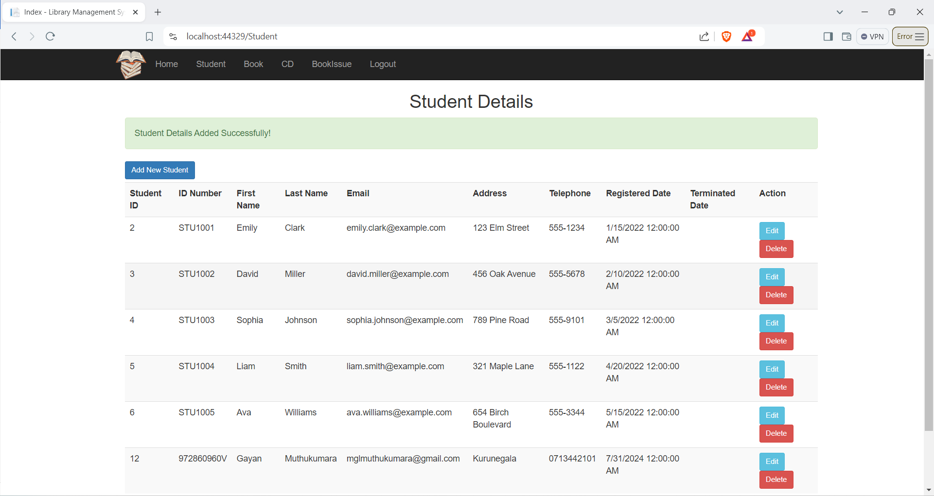

Figure 20 : Student Add Successfully Page

Edit Student

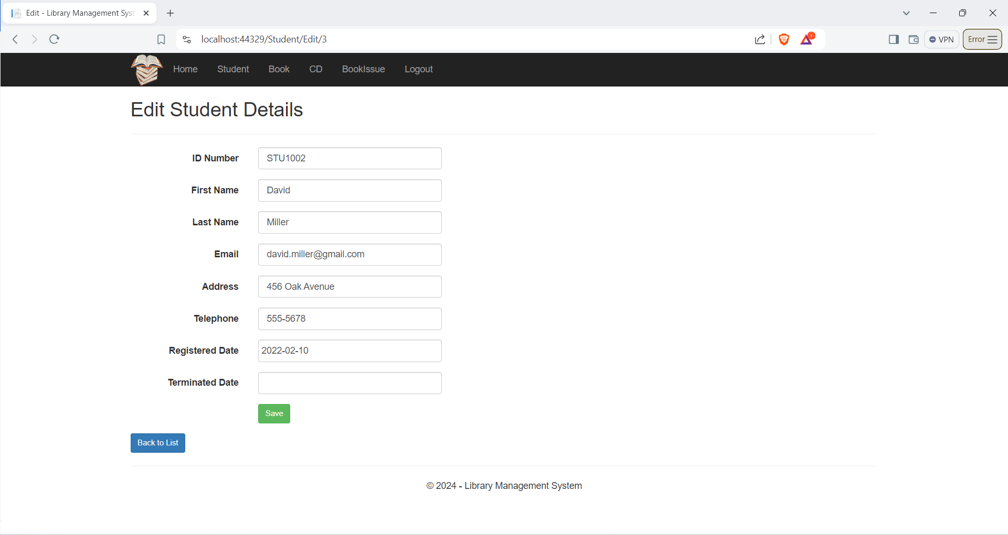

Figure 21 : Edit Student Page

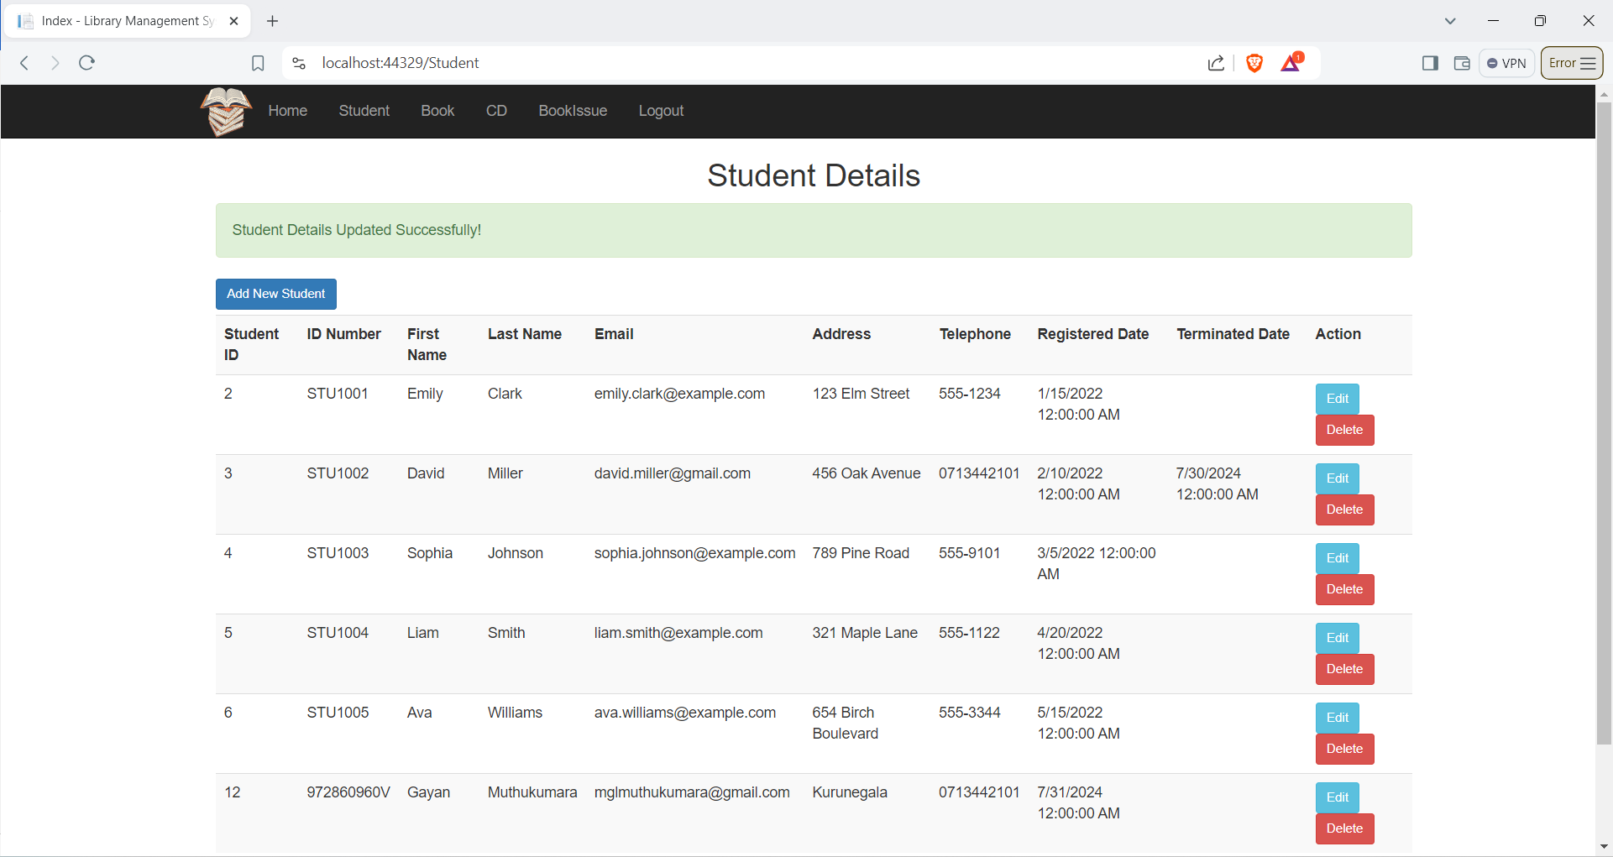

Figure 22 : Student Details Edit Successfully Page

Delete Student

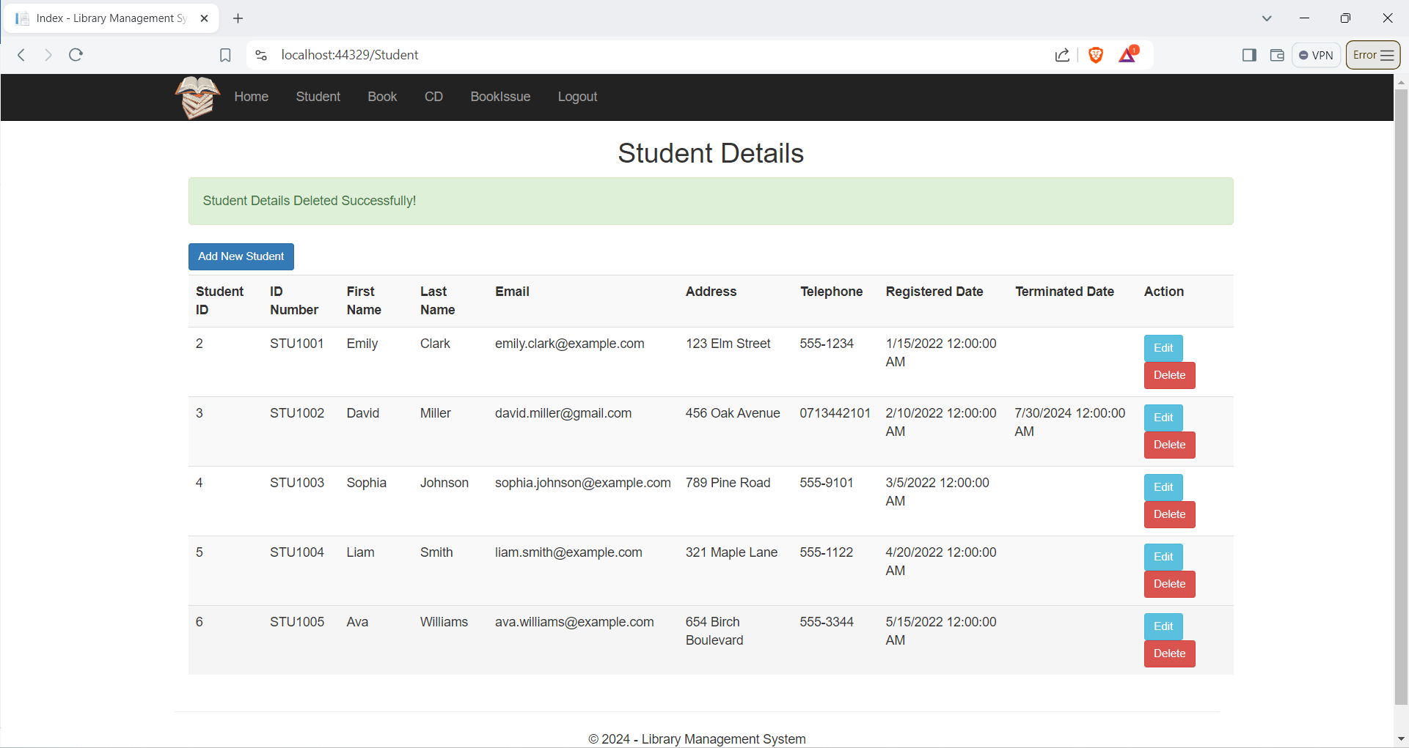

Figure 23: Delete Student Page

Book Page

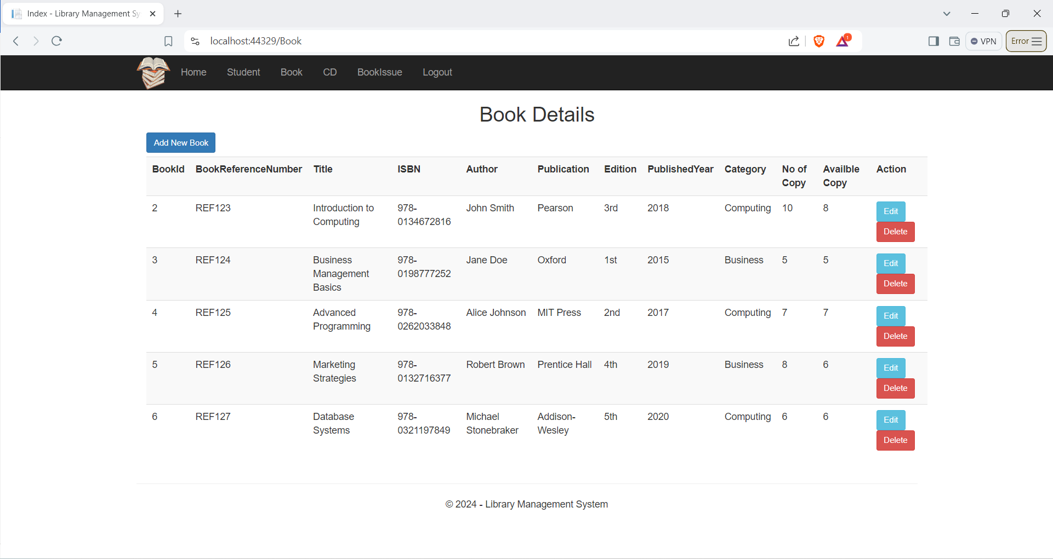

Figure 24: Book Page

Add Book

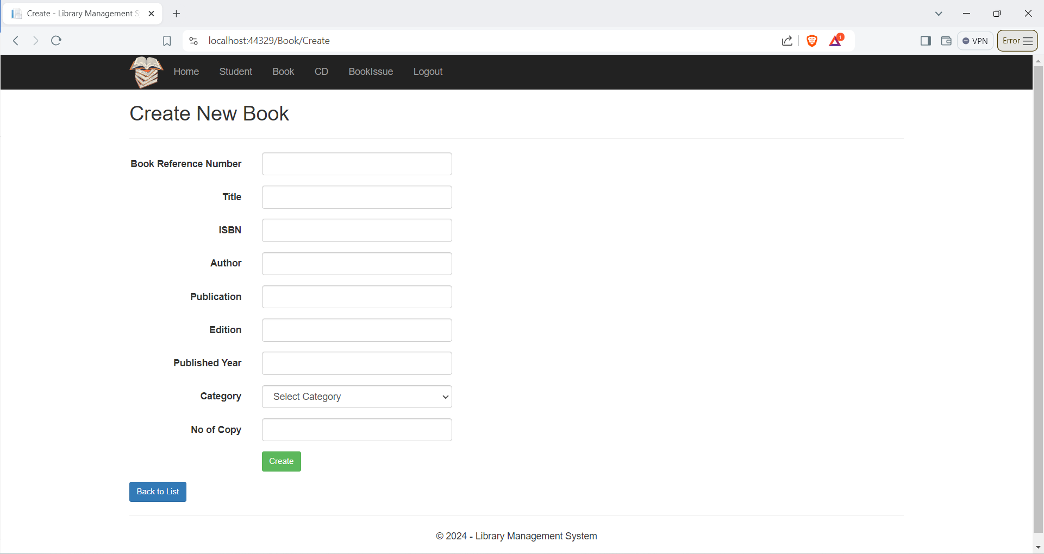

Figure 25: Add Book Details

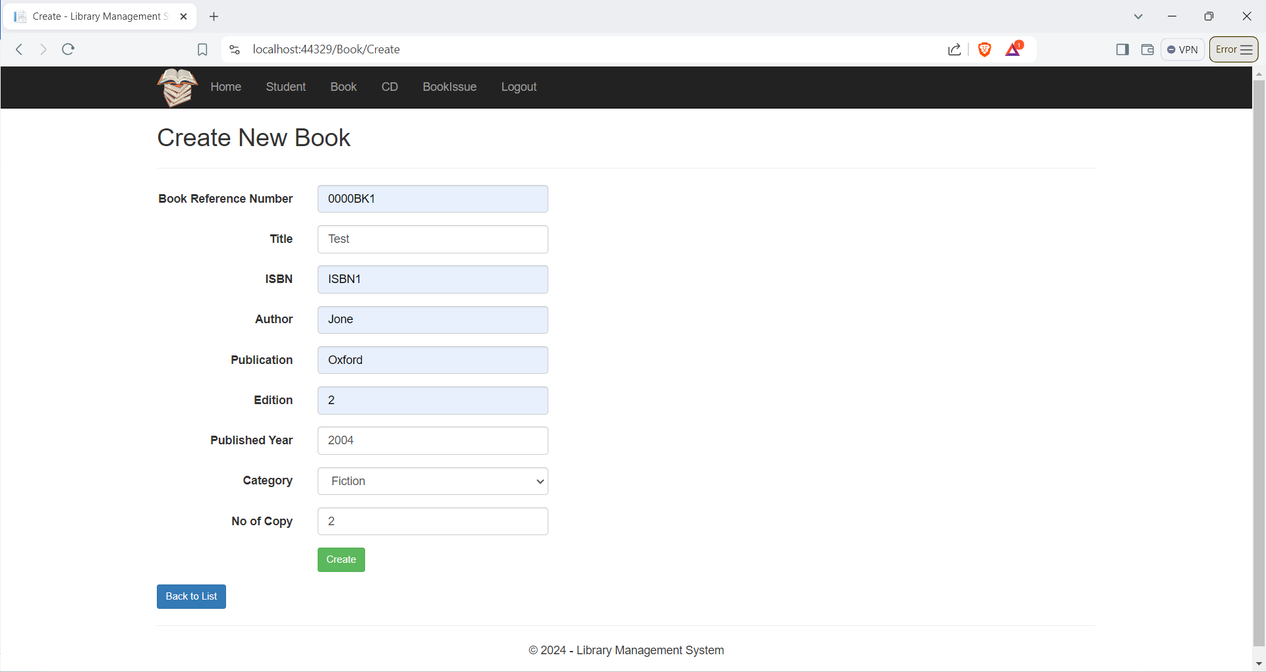

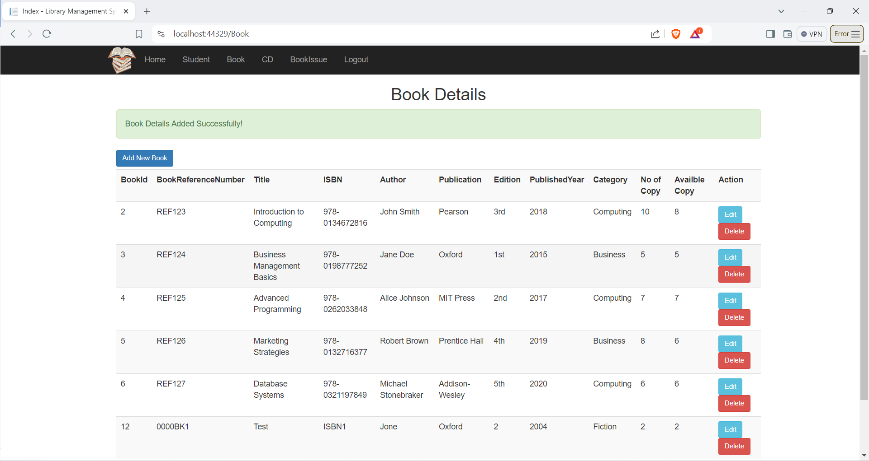

Edit Book

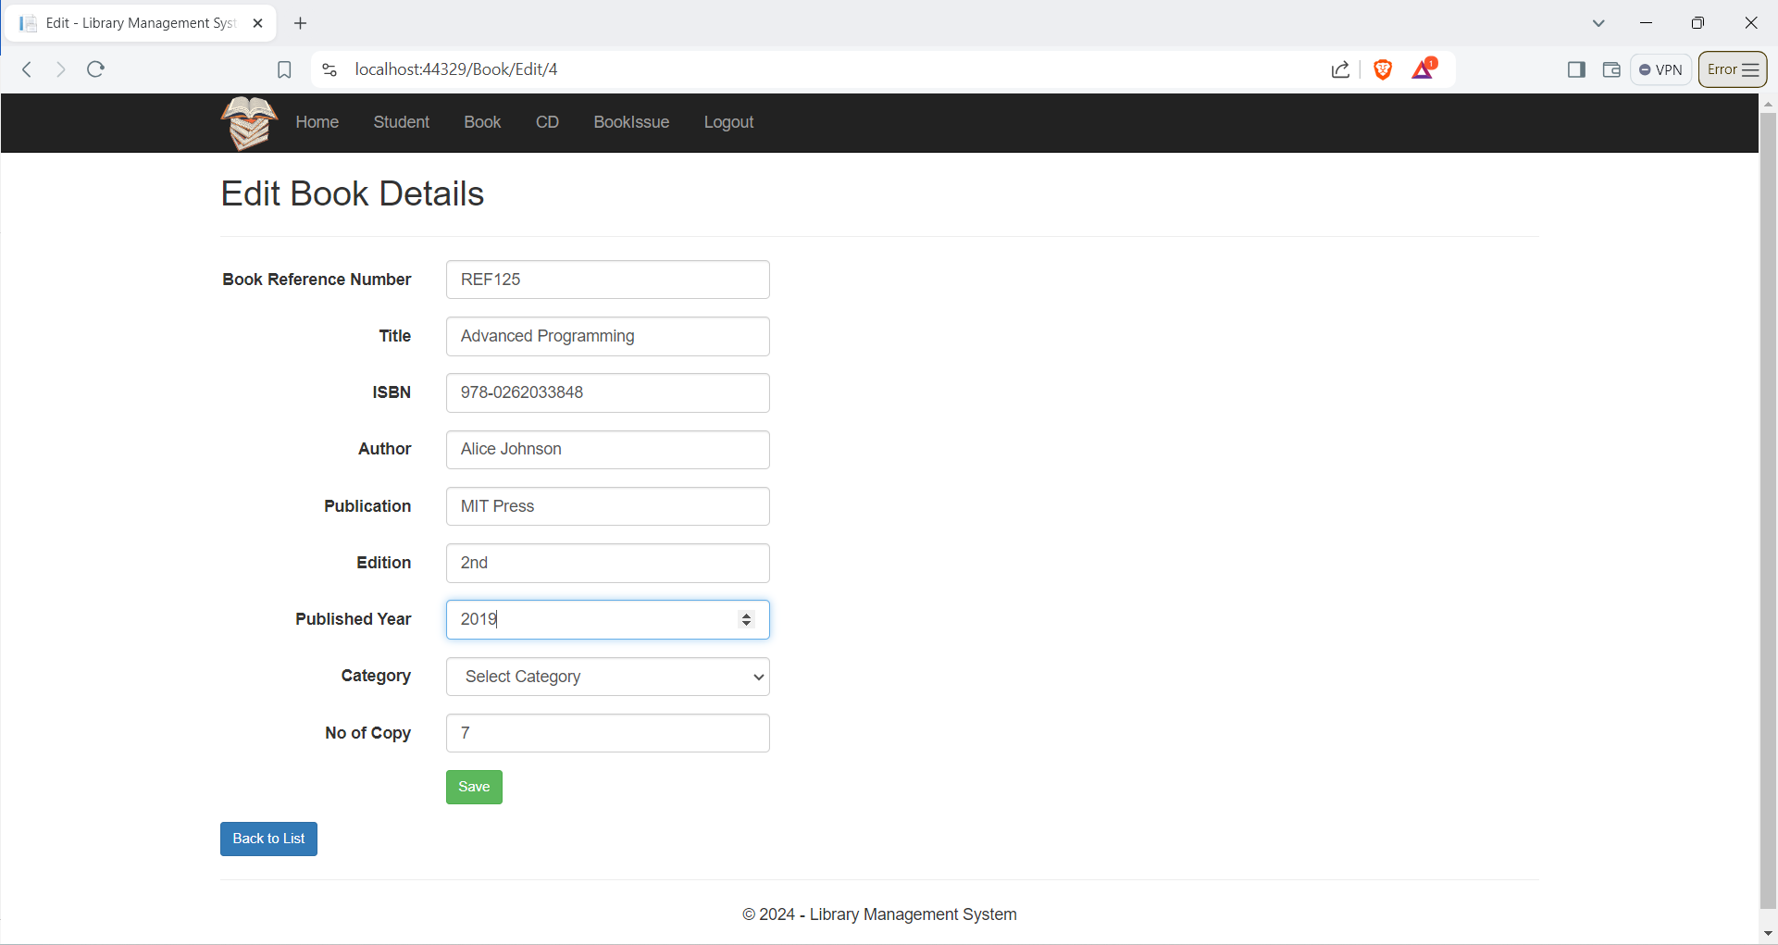

Figure 26: Edit Book Details

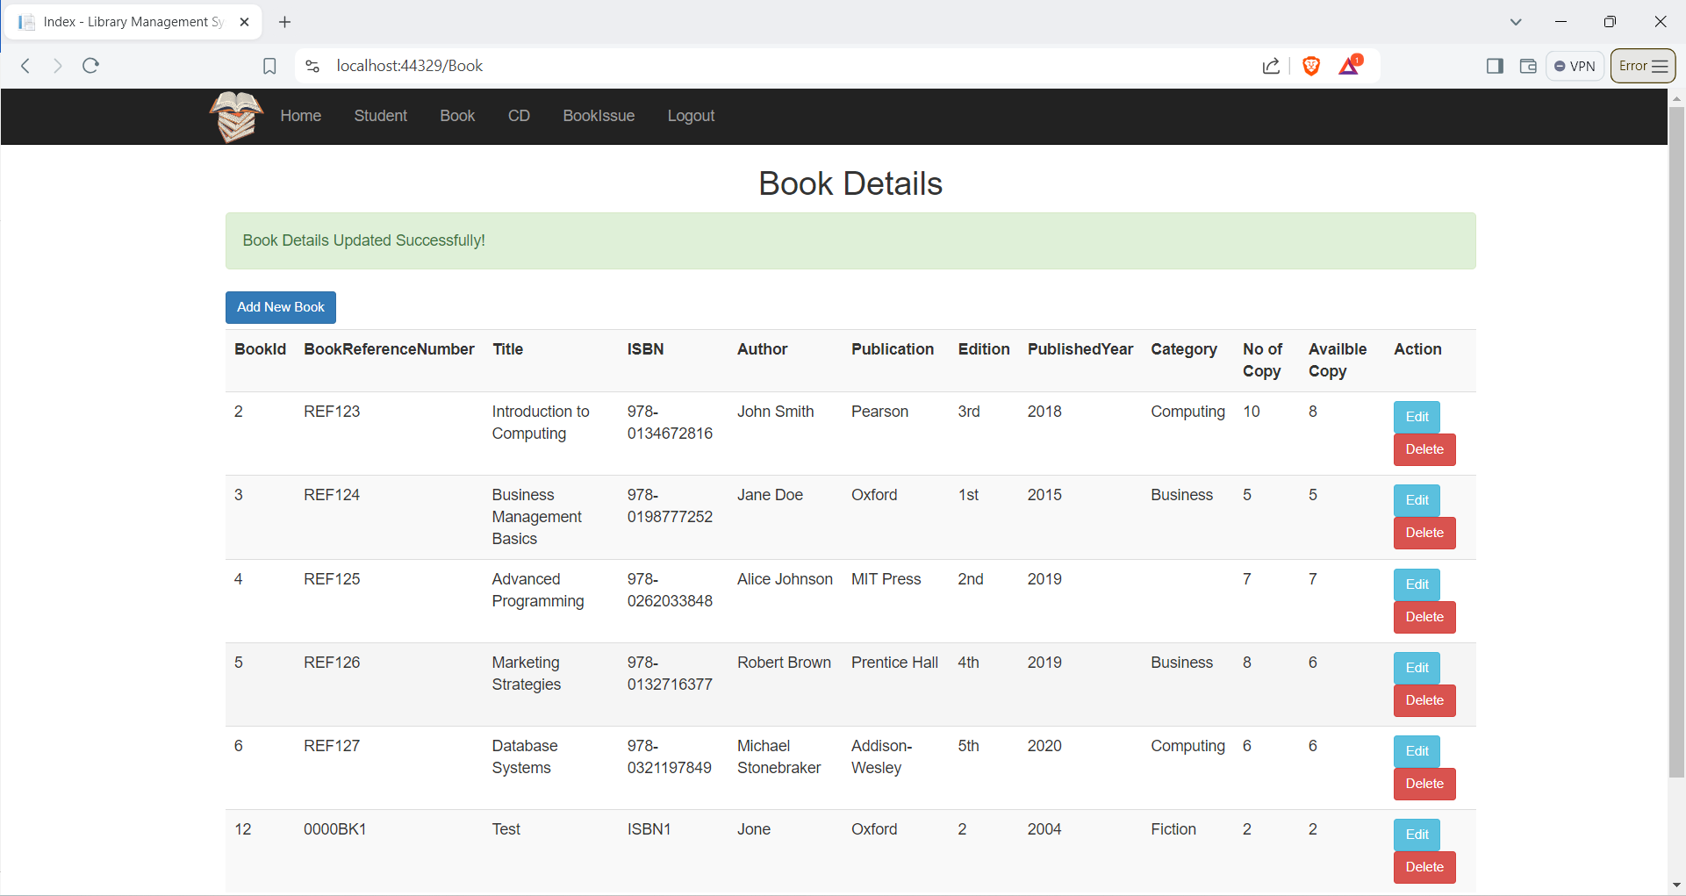

Delete Book

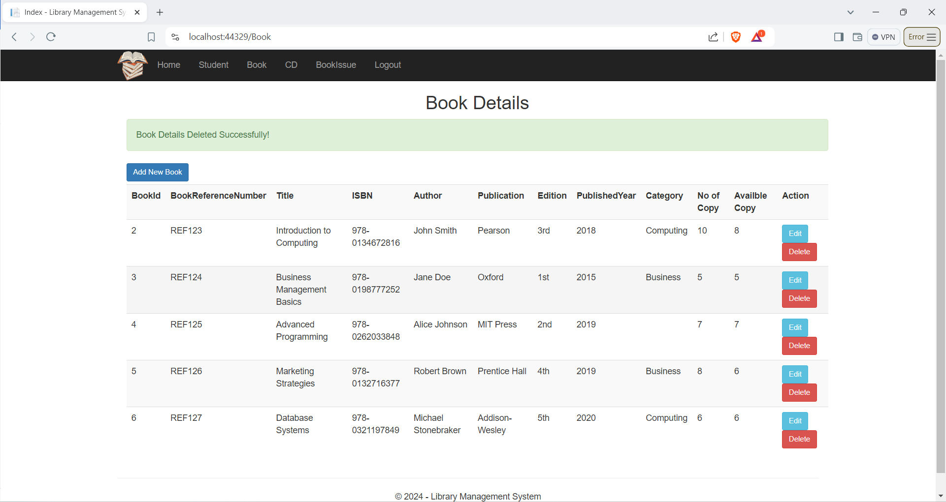

Figure 27: Delete Book Details

CD Page

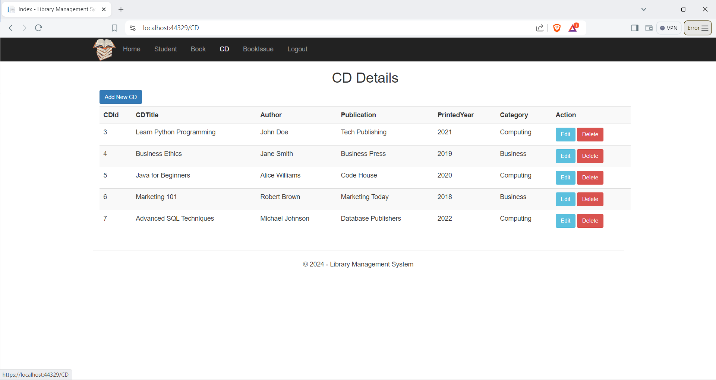

Figure 28: CD Page

Add CD

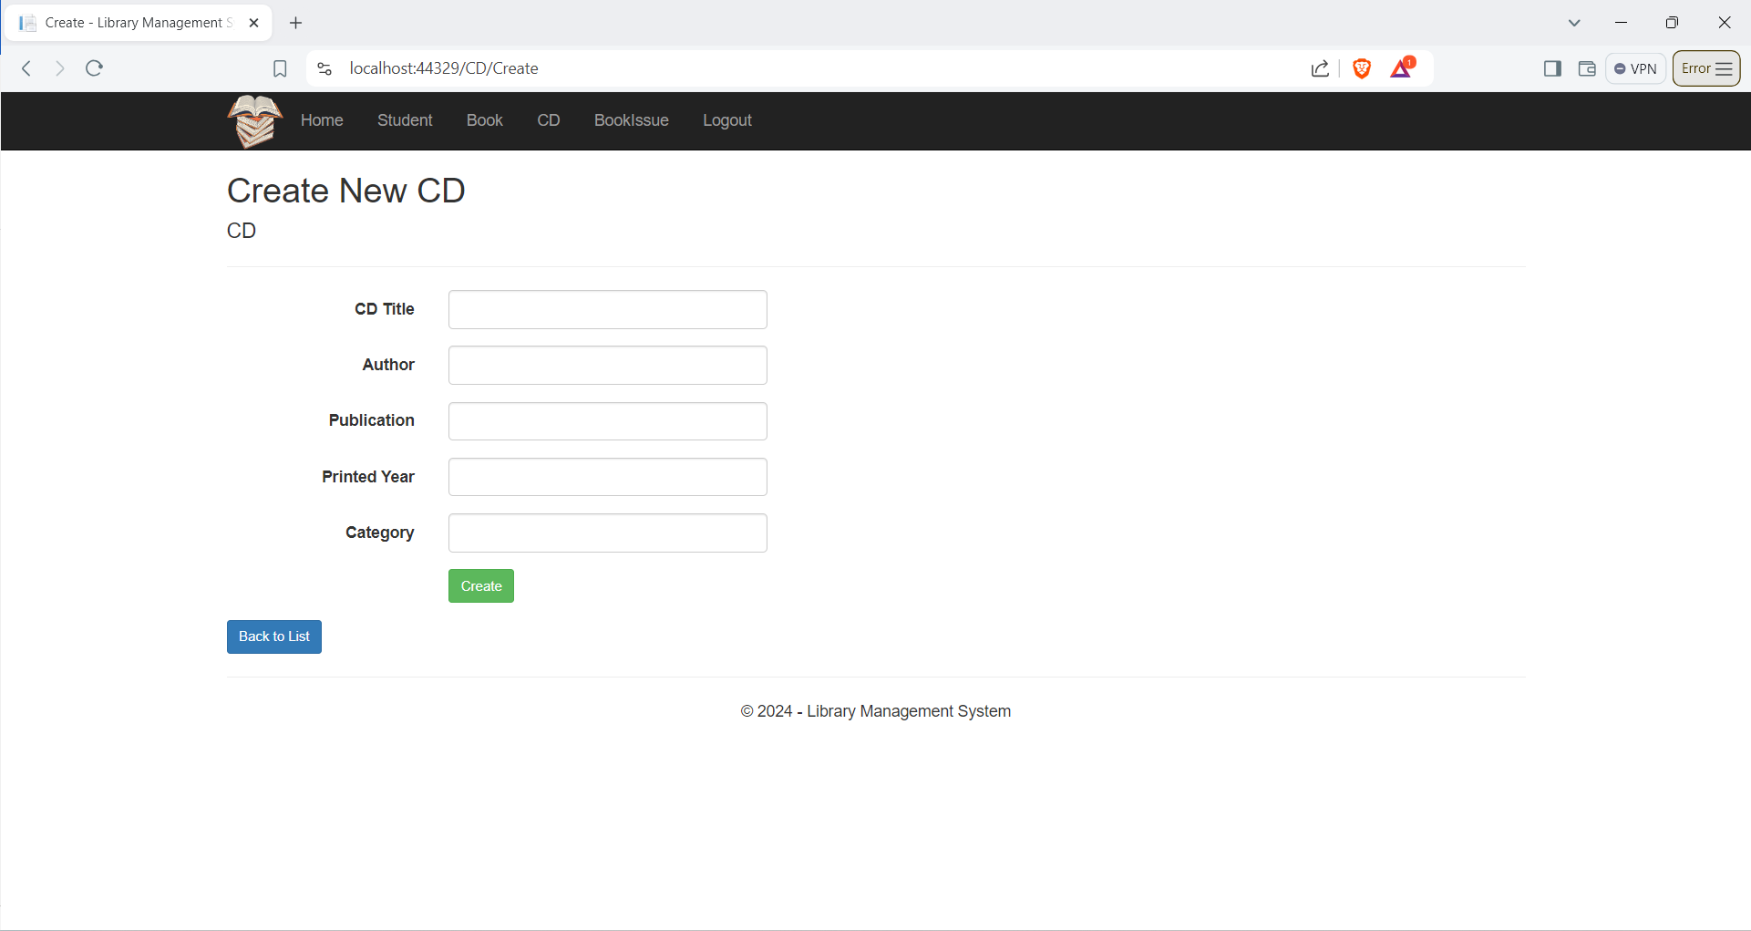

Figure 29 : Add CD Details

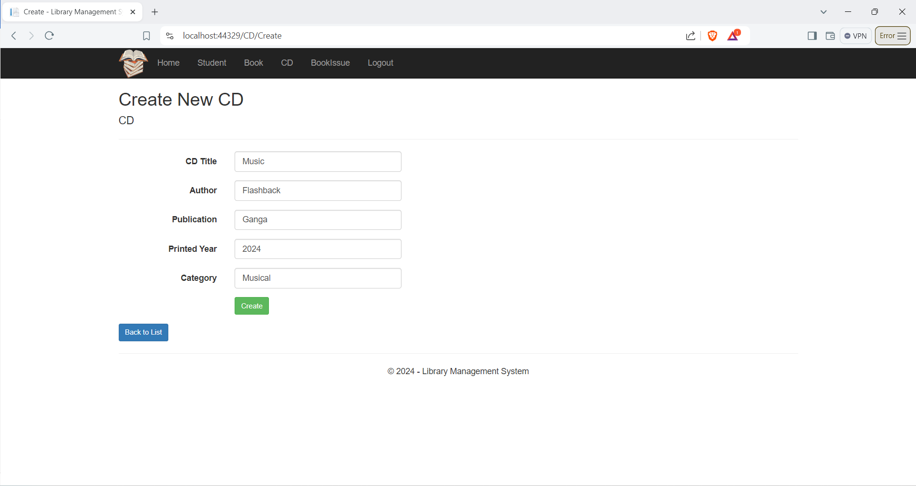

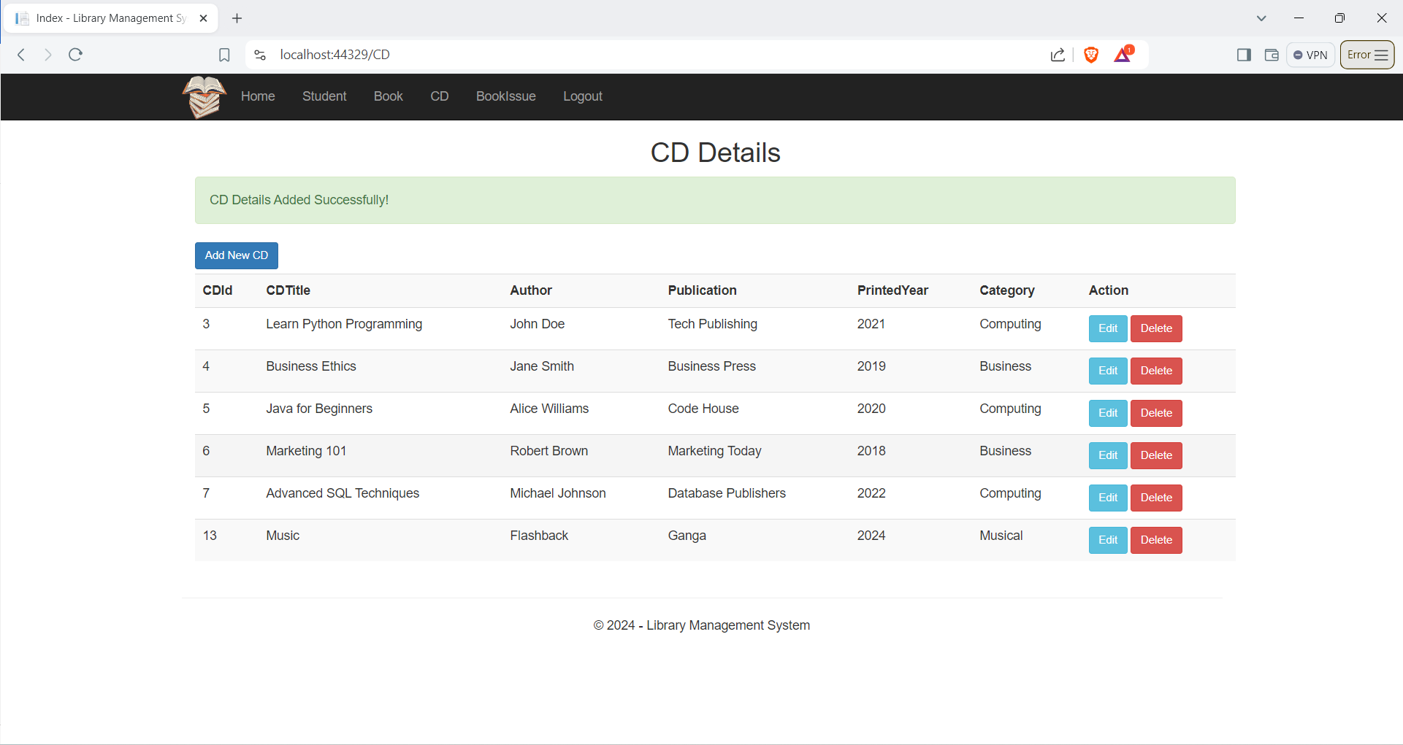

Edit CD

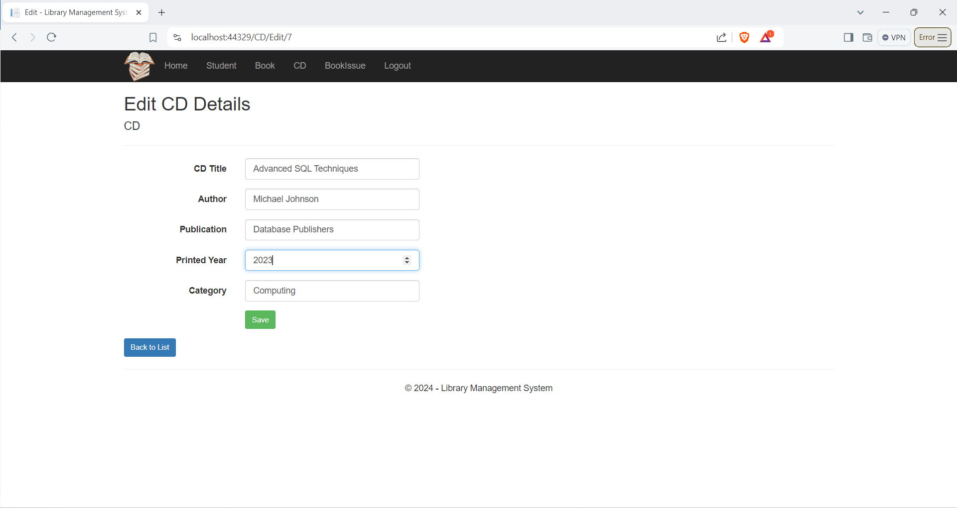

Figure 30: Edit CD Details

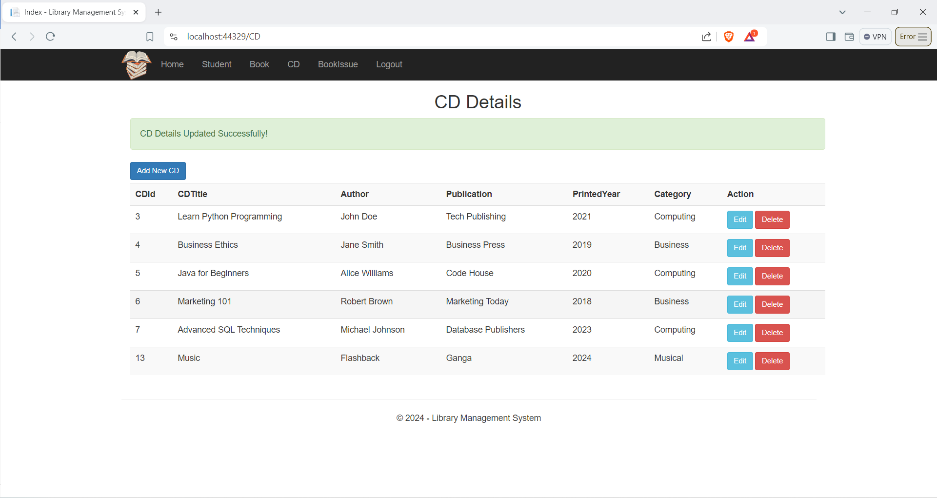

Delete CD

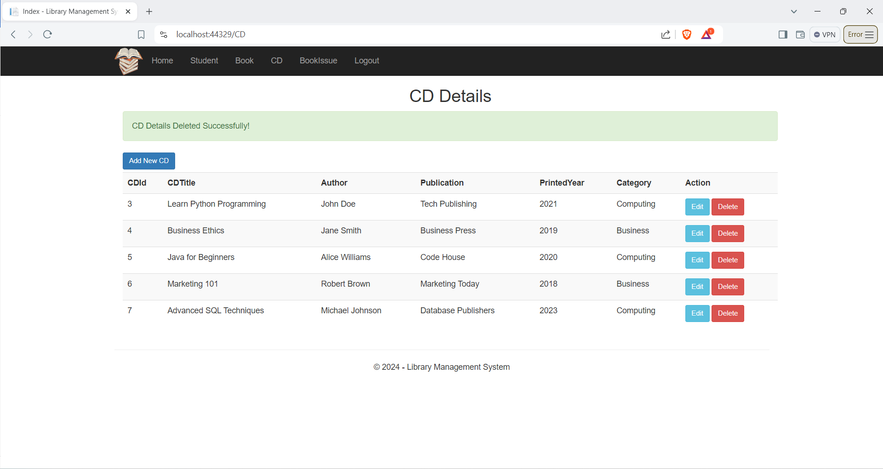

Figure 31: Delete CD Details

Book Issue Page

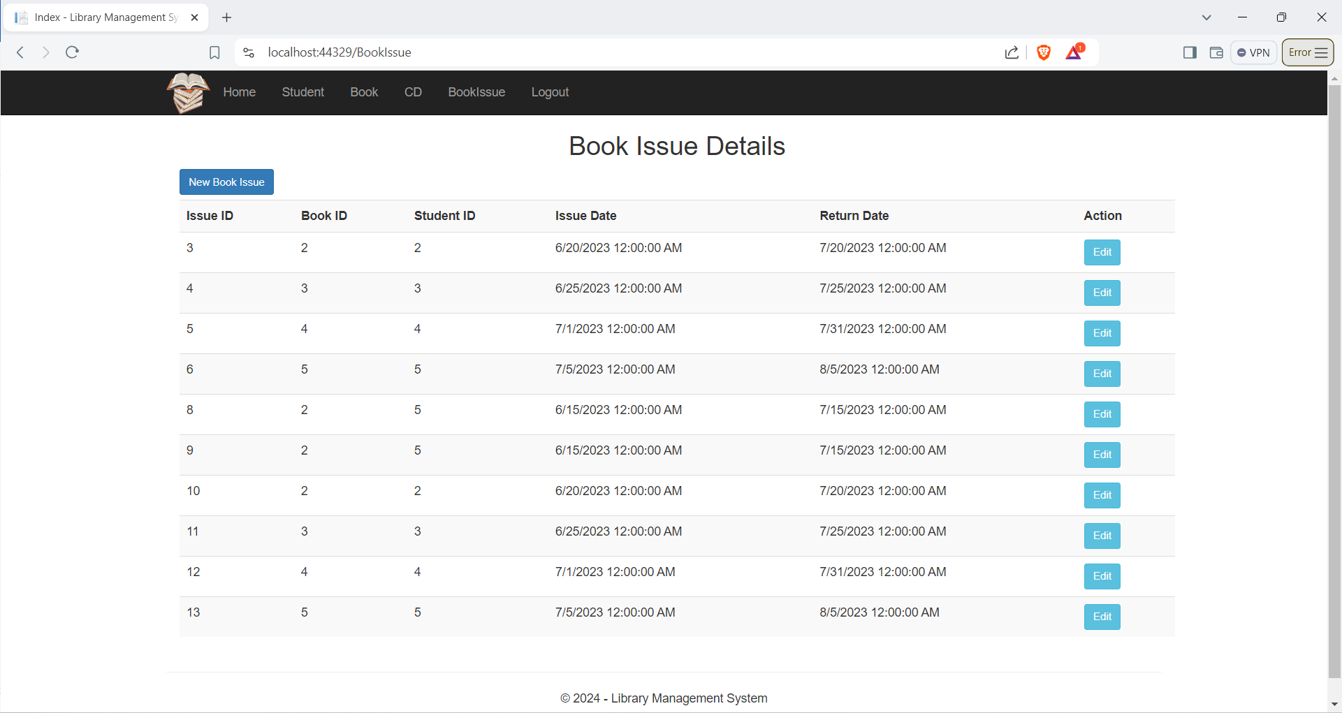

Figure 32 : Issue Book Page

New Book Issue

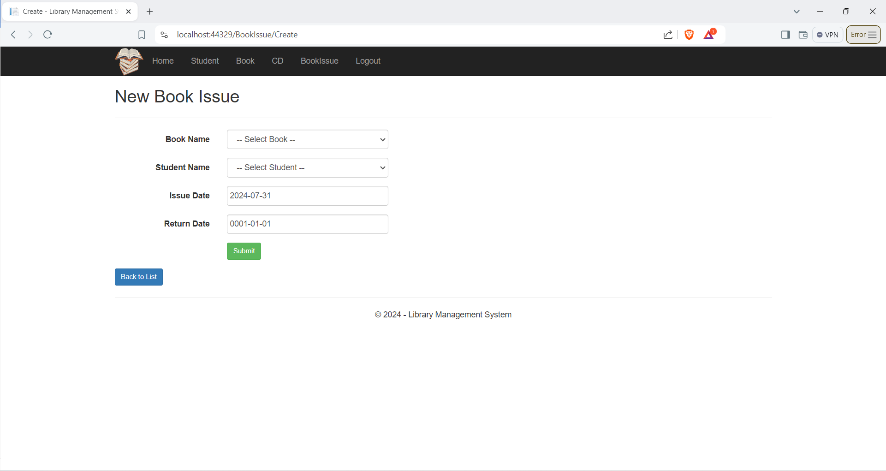

Figure 33: New Book Issue Page

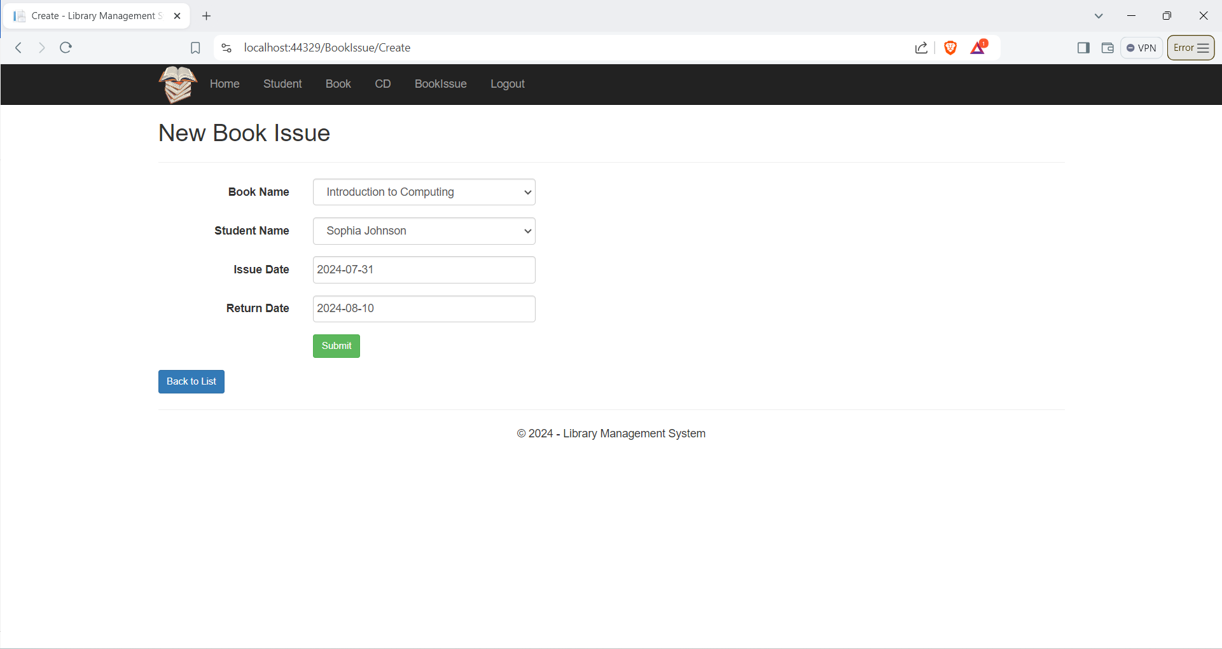

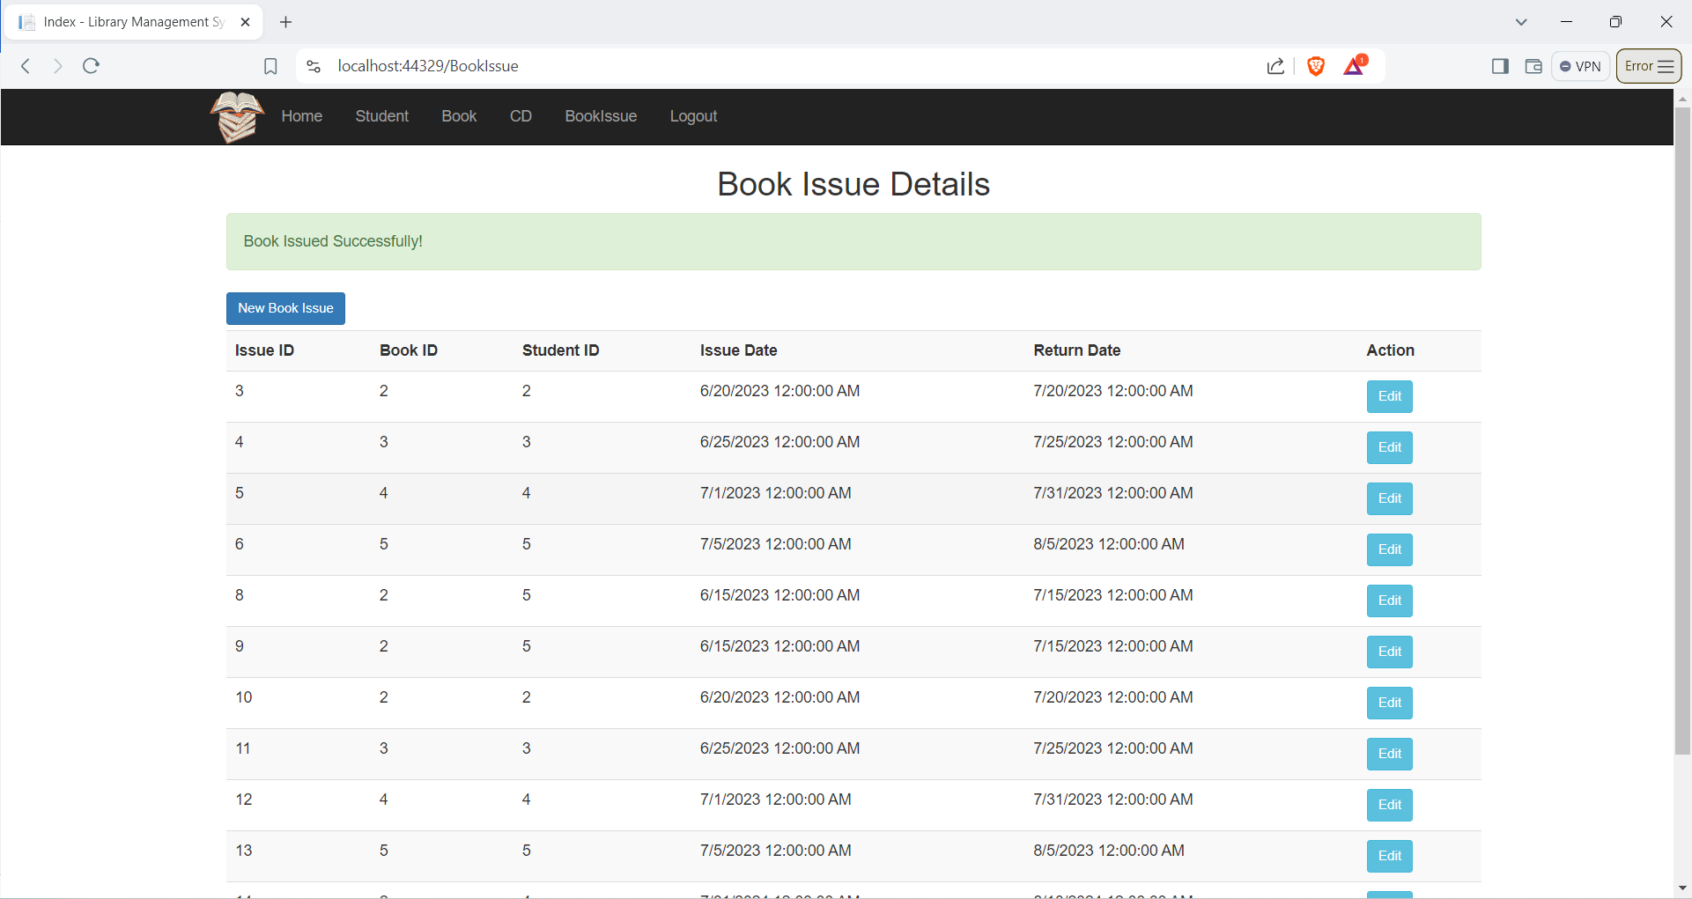

Search Book Page

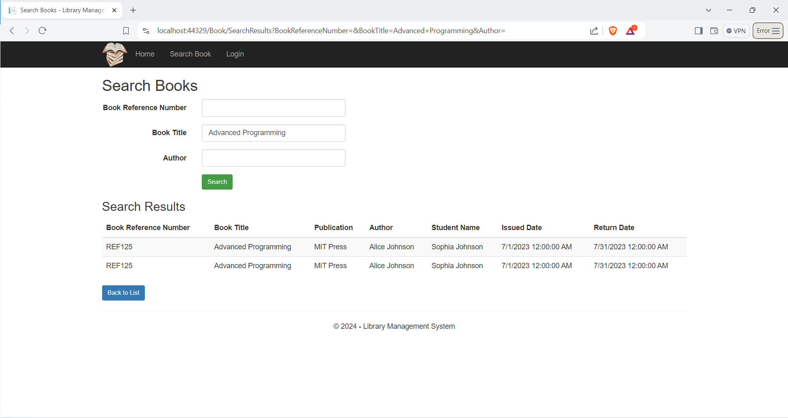

Figure 34: Search page

# Testing

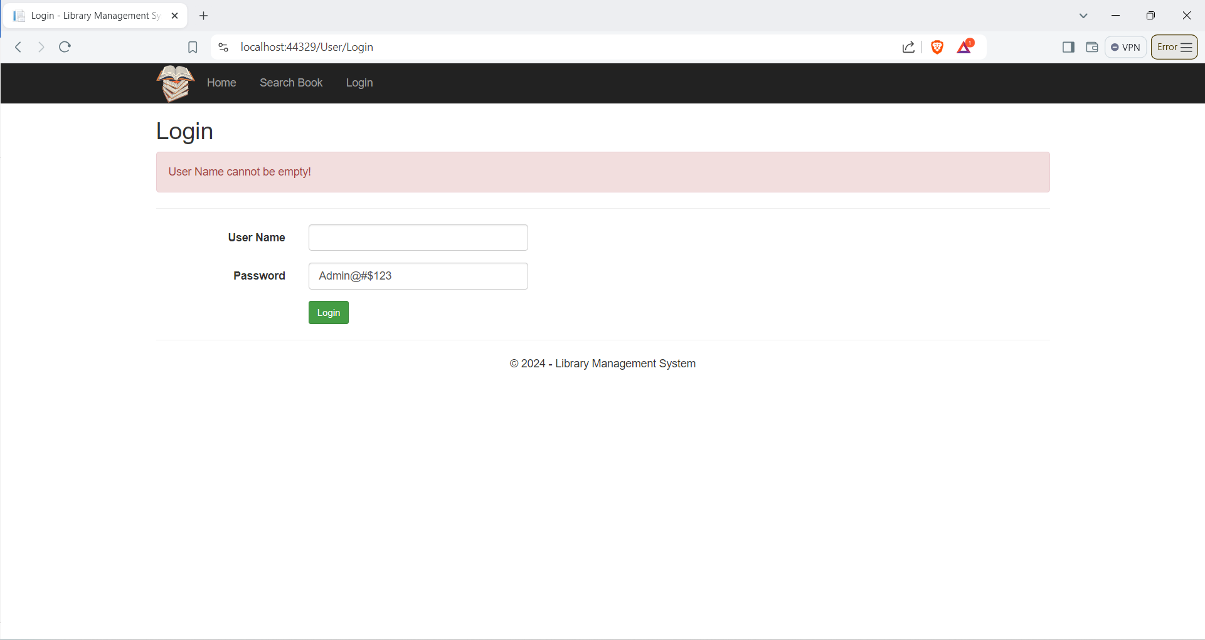

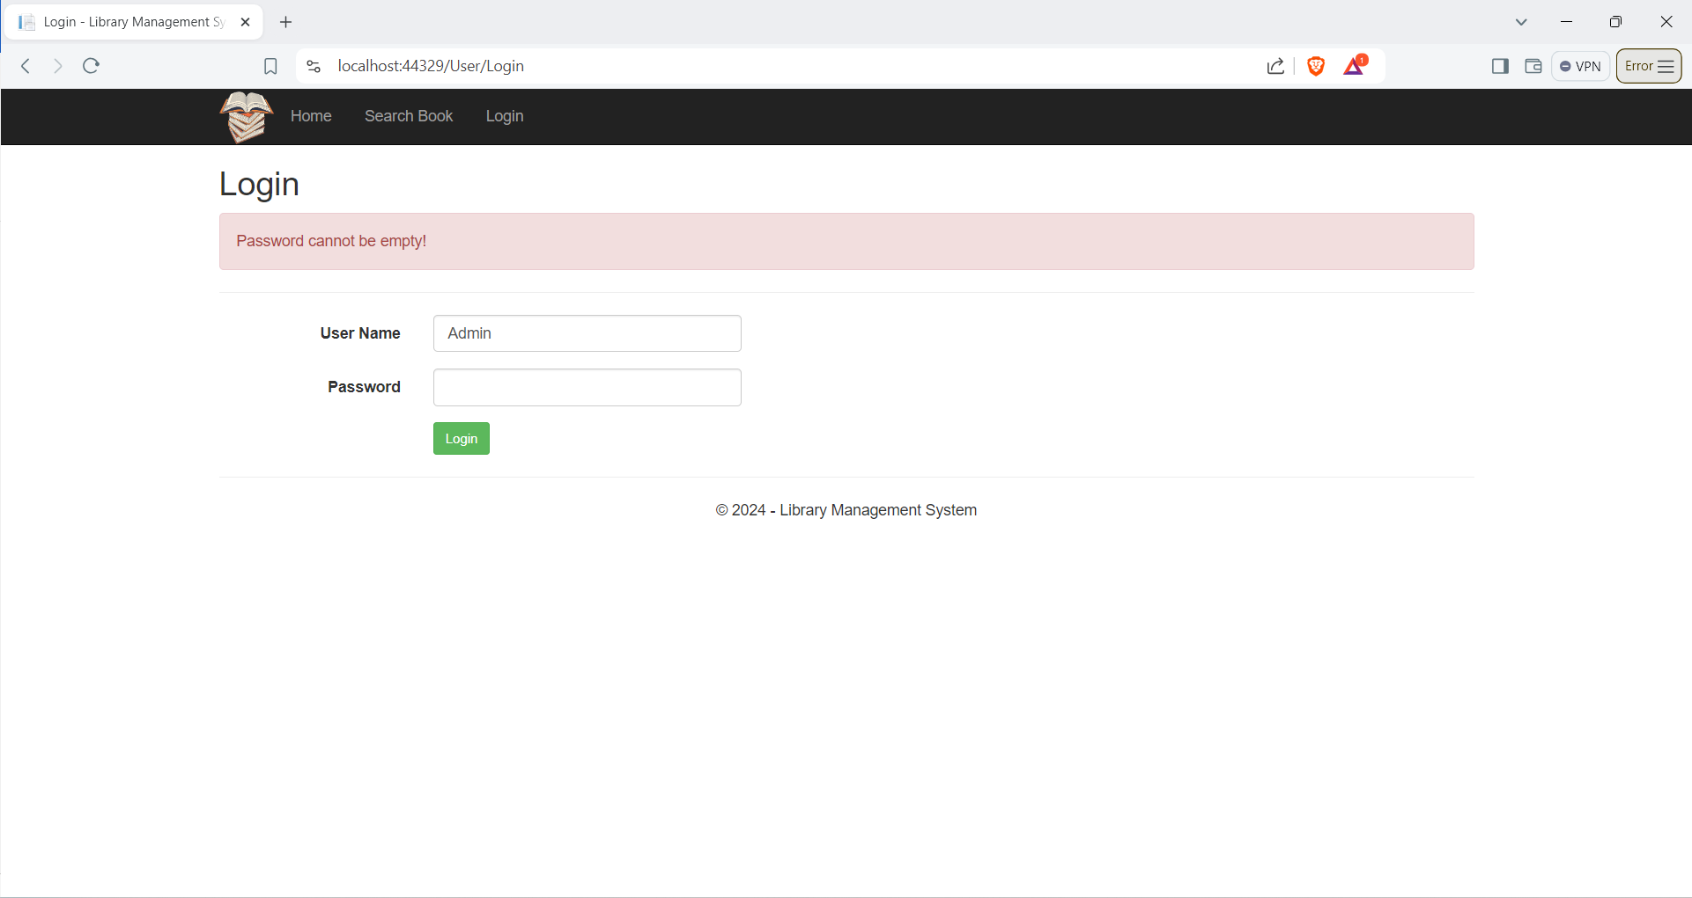

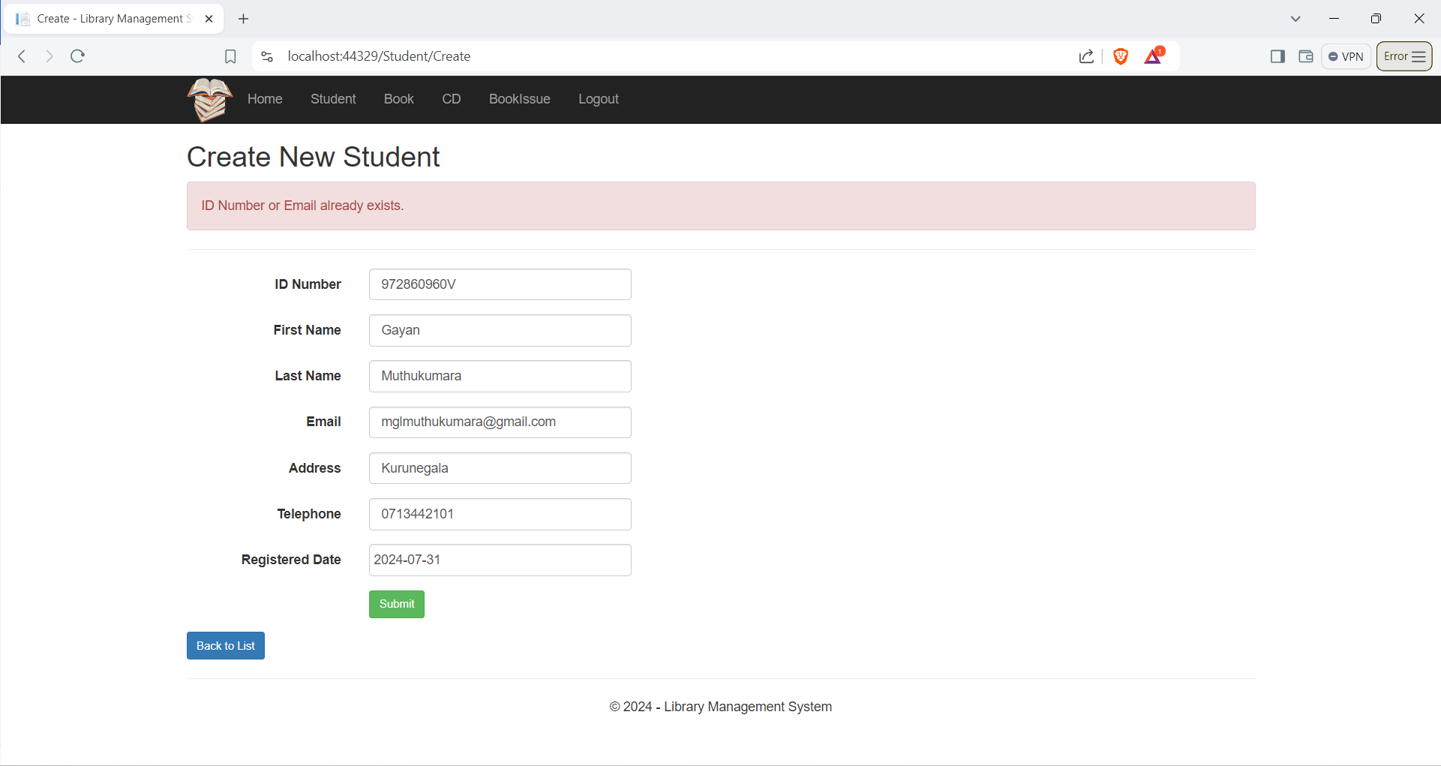

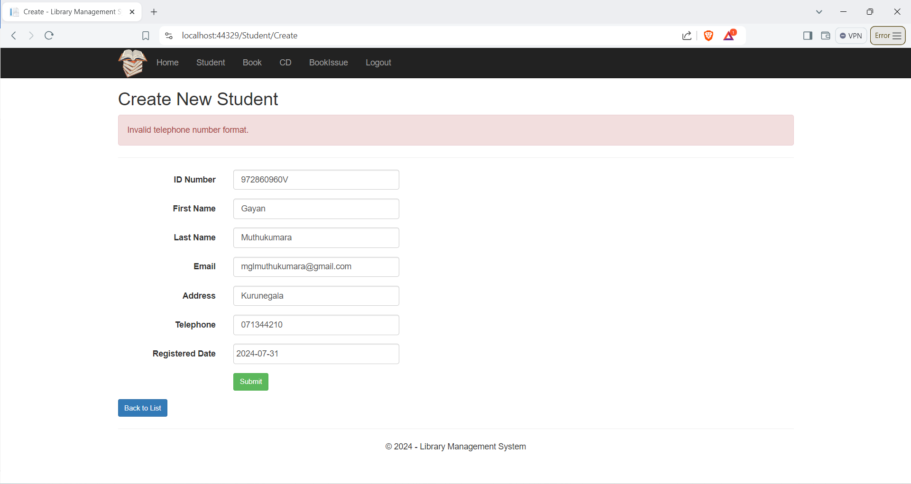

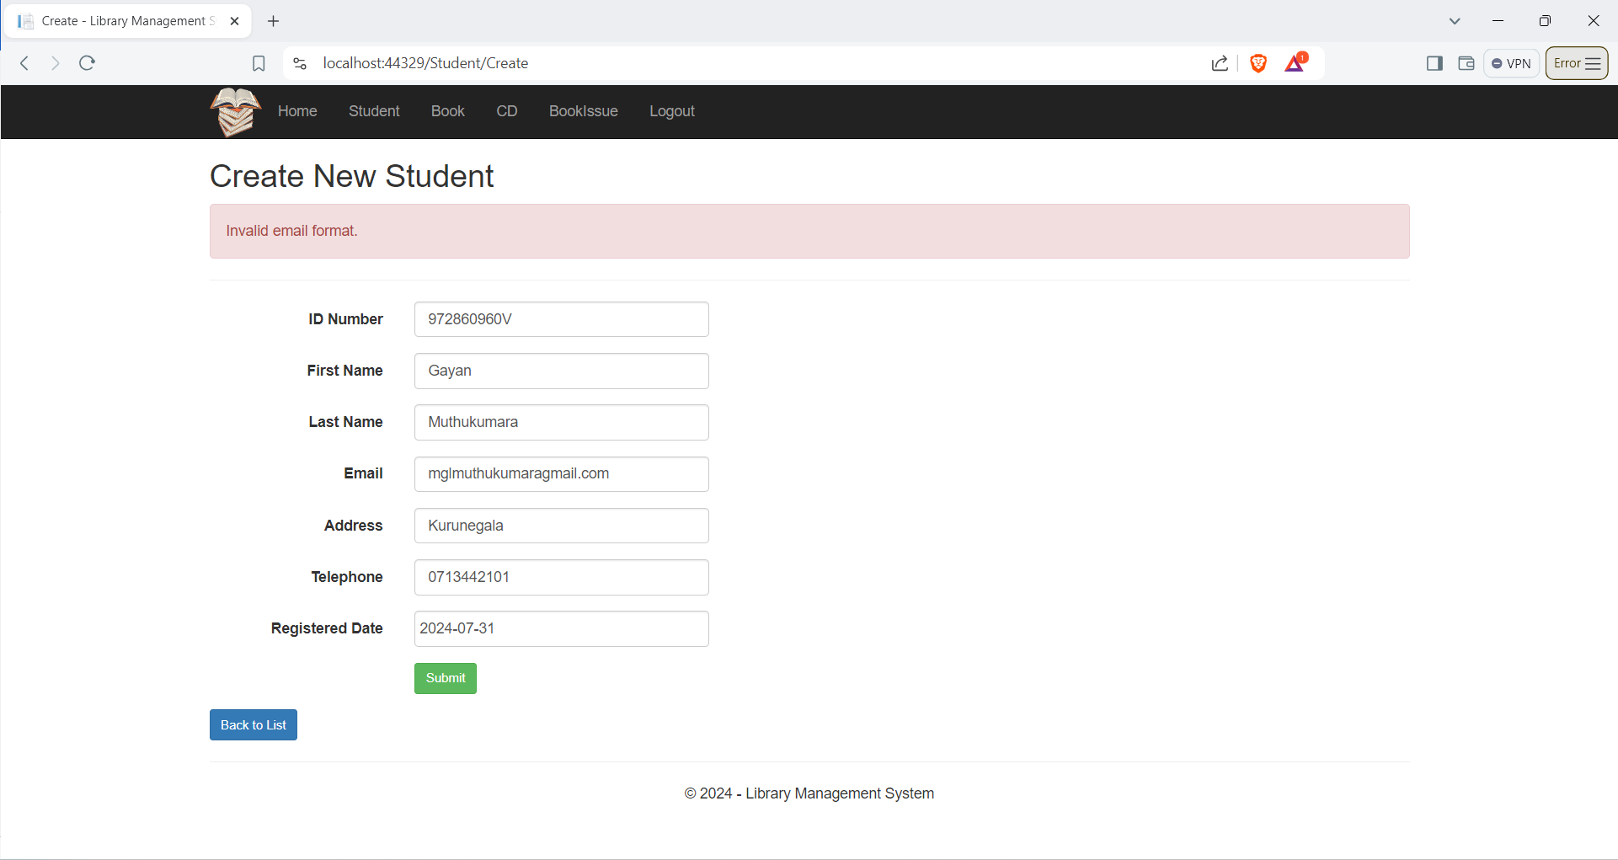

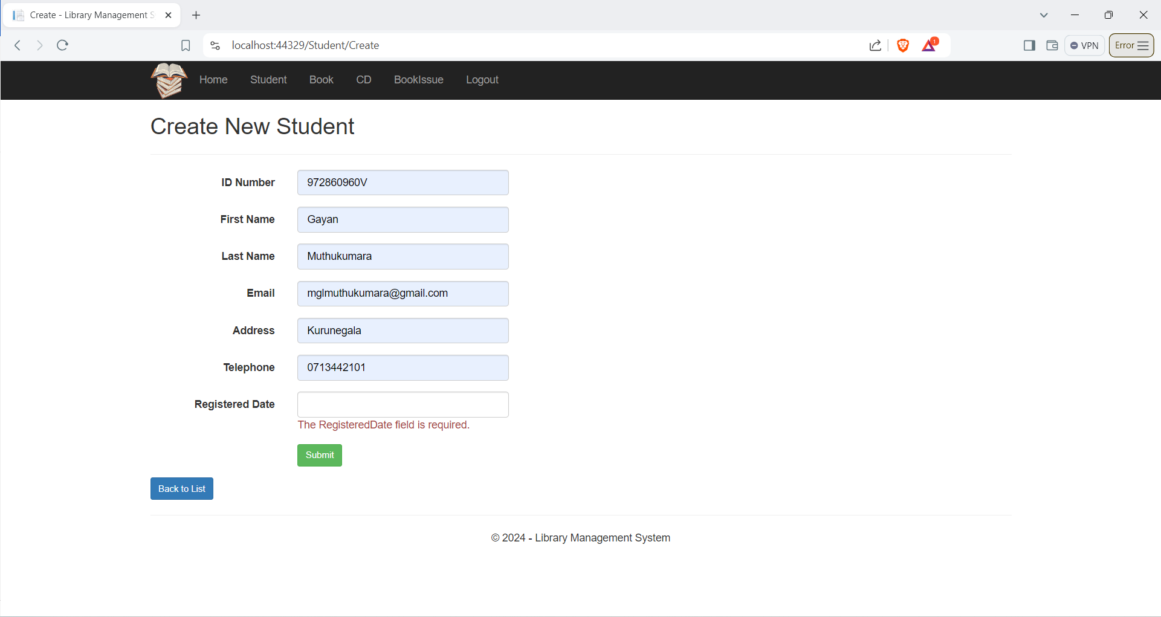

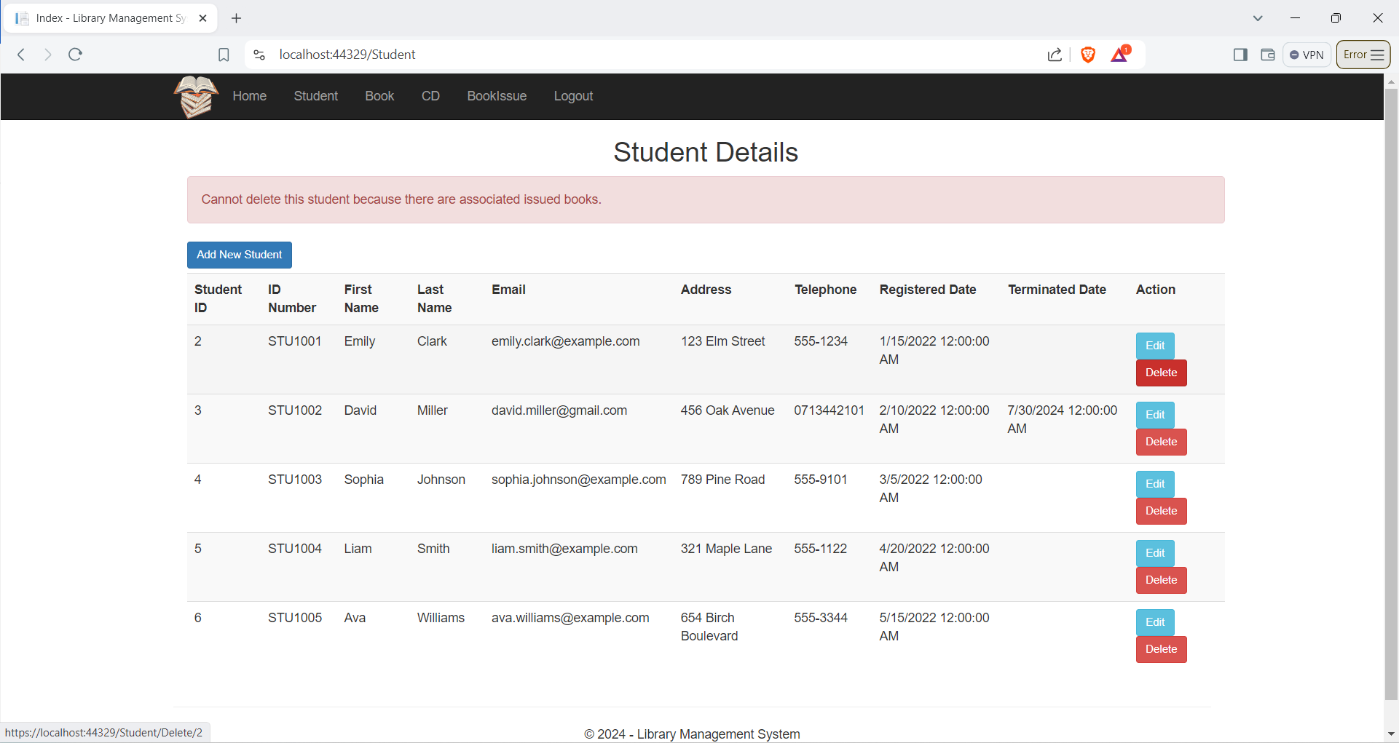

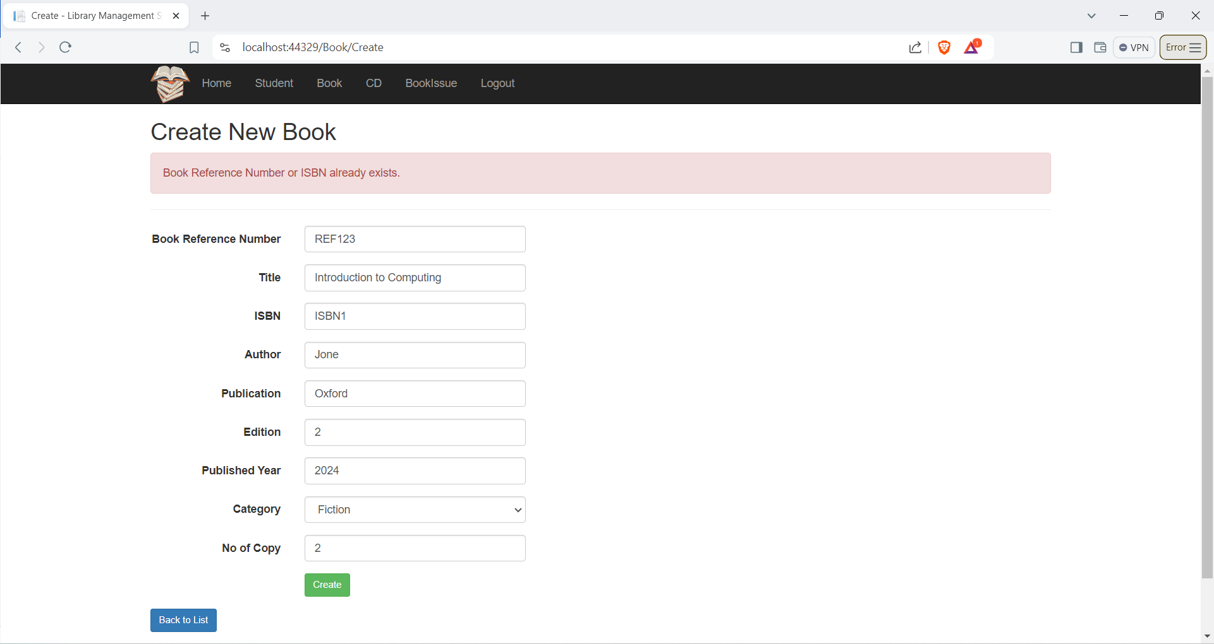

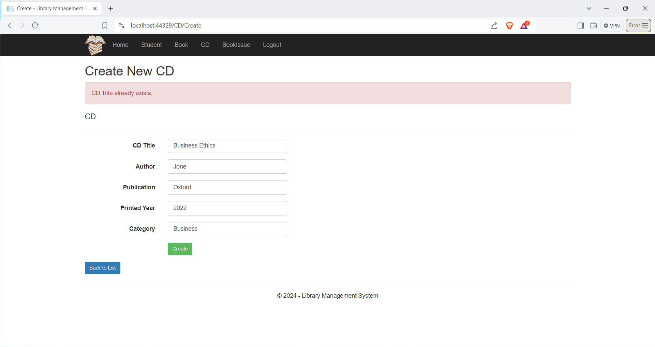

# User manual

**Sign in**

Once admin visits the website, the sign-in page will be displayed. The admin can sign in to the website using the preset username and password.

**Adding a student to the system**

Admin can click the “student” tab in the header. It will directs admin to the page where all the student details are displayed. In the top left coner of the student details table, there is a button as Ädd New Student”. Once admin clicks that button, it will directs admin to a form where admin needs to fill the new student’s details. Clicking the “Save” button will save the data successfully.

**Edit and delete an existing student's details**

In the student page, the final column of the student details table is “action”. Select the edit button in “action” column which is relevant to the student of whom admin needs to edit the details. Once the Edit button is clicked, already filled student details form will be displayed. Then admin needs to edit the details and save using the “Save” button in the bottom of the form.

Student details can be deleted using the “Delete” button in the “Action” column.

**Add new book details**

Admin can click the “Book” tab in the header. It will directs admin to the page where all the book details are displayed. In the top left coner of the book details table, there is a button as “Add New Book”. Once admin clicks that button, it will directs admin to a form where admin needs to fill the new book’s details. Clicking the “Save” button will save the data successfully.

**Edit and delete an existing books’ details**

In the Book page, the final column of the student details table is “action”. Select the edit button in “action” column which is relevant to the book of which admin needs to edit the details. Once the Edit button is clicked, already filled book details form will be displayed. Then admin needs to edit the details and save using the “Save” button in the bottom of the form.

book details can be deleted using the “Delete” button in the “Action” column.

**Adding a CD to the system**

Admin can click the “CD” tab in the header. It will directs admin to the page where all the CD details are displayed. In the top left coner of the CD details table, there is a button as “Add New CD”. Once admin clicks that button, it will directs admin to a form where admin needs to fill the new CD details. Clicking the “Save” button will save the data successfully.

**Edit and delete an existing CD details**

In the CD page, the final column of the CD details table is “action”. Select the edit button in “action” column which is relevant to the CD of which admin needs to edit the details. Once the Edit button is clicked, already filled CD details form will be displayed. Then admin needs to edit the details and save using the “Save” button in the bottom of the form.

CD details can be deleted using the “Delete” button in the “Action” column.

**Issue a book**

Admin can click the “IssueBook” tab in the header. It will directs admin to the page where all the Book issue details are displayed. In the top left coner of the Book issue details table, there is a button as “Issue Book”. Once admin clicks that button, it will directs admin to a form where admin needs to fill the new book issuing details. Book name and the student name should be selected from the drop down list. Only the available book details and active student details will be displayed. Clicking the “Submit” button will save the data successfully.

**Seach book**

Search Book header can be seen in the welcome page of the website. In header the is a header as Search book and after clicking that search filter form will be opened.

# Further discussion

The Library Management System for Sydenham Library began with a comprehensive planning phase, involving discussions with stakeholders to understand the project's scope and requirements. The database schema was designed, including tables for books, students, issued books, CDs, and admin users, with foreign key constraints to maintain relationships. This required a deep understanding of SQL and relational database principles.  
  
The next phase involved implementing Create, Read, Update, and Delete (CRUD) operations for various entities within the system, requiring writing robust SQL queries and stored procedures. The data access layer in the application code was another crucial component, using ADO.NET to develop methods to interact with the database, handling connections, executing commands, and reading data.  
  
The database design was a critical part of the project, collaborating with front-end developers to ensure alignment with user interface requirements. Testing and debugging were conducted throughout the development process to ensure system reliability and performance. This included unit testing individual components, integration testing, and user acceptance testing to gather feedback from stakeholders. Debugging issues, particularly those related to database transactions and data integrity, provided hands-on experience in troubleshooting and resolving complex issues, ensuring the system was robust and error-free.